

**Mesa Verde® Ice Plant**

*Delosperma* ‘Kelaidis’ PP13,876

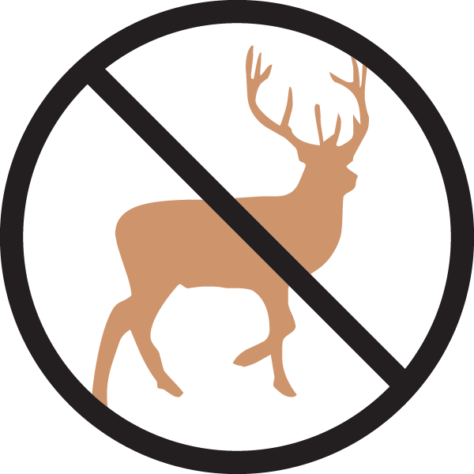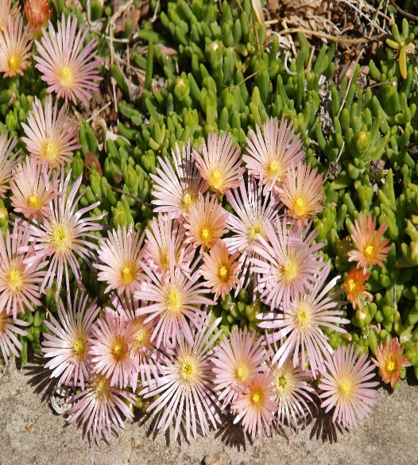

**Height: 2 in. Width: 10-14 in.**

This iridescent, salmon-pink flowered ice plant appeared among plants of a dwarf, alpine form of *Delospermum cooperi* at Denver Botanic Gardens in 1997. It is vigorous, compact and floriferous.

**Culture:** Clay, loam or gravelly soil

**Hardiness:** USDA zones 4b-8

www.plantselect.org



WIND. HAIL. SNOW. SUN

**BRING IT ON**

