
Lavender Ice Ice Plant
Delosperma ‘Psfave’



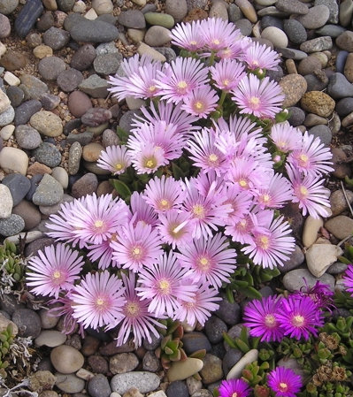

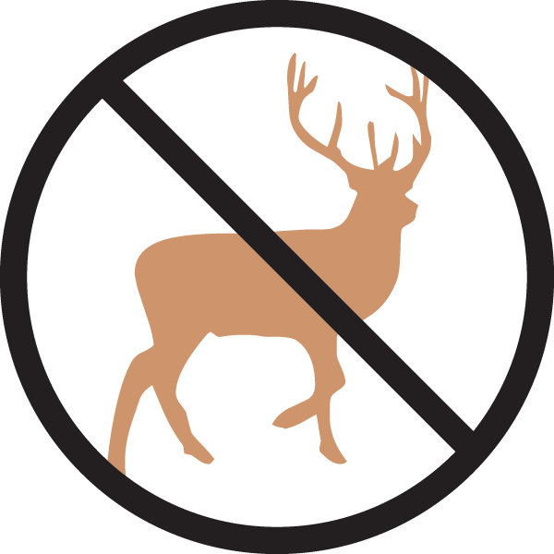



Height: 2 in. Width: 18-22 in.
A fantastic color breakthrough in ice plants! Iridescent lavender with a dark eye, this striking sport of Table Mountain® occurred at Perennial Favorites nursery in Rye, Colorado. Trim green mats purplish in winter.
Culture: Clay, loam or sandy soil
Hardiness: USDA zones 4-9



WIND. HAIL. SNOW. SUN
BRING IT ON

www.plantselect.org



