

**Lavender Ice Ice Plant**

*Delosperma ‘Psfave’*

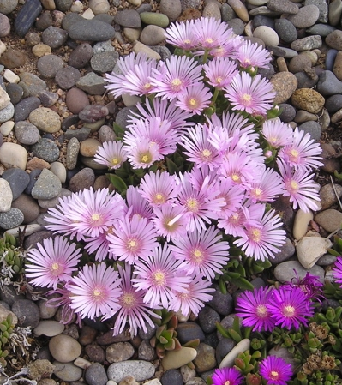

**Height: 2 in. Width: 18-22 in.**

A fantastic color breakthrough in ice plants! Iridescent lavender with a dark eye, this striking sport of Table Mountain® occurred at Perennial Favorites nursery in Rye, Colorado. Trim green mats purplish in winter.

**Culture:** Clay, loam or sandy soil

**Hardiness:** USDA zones 4-9



WIND. HAIL. SNOW. SUN

**BRING IT ON**

www.plantselect.org

