

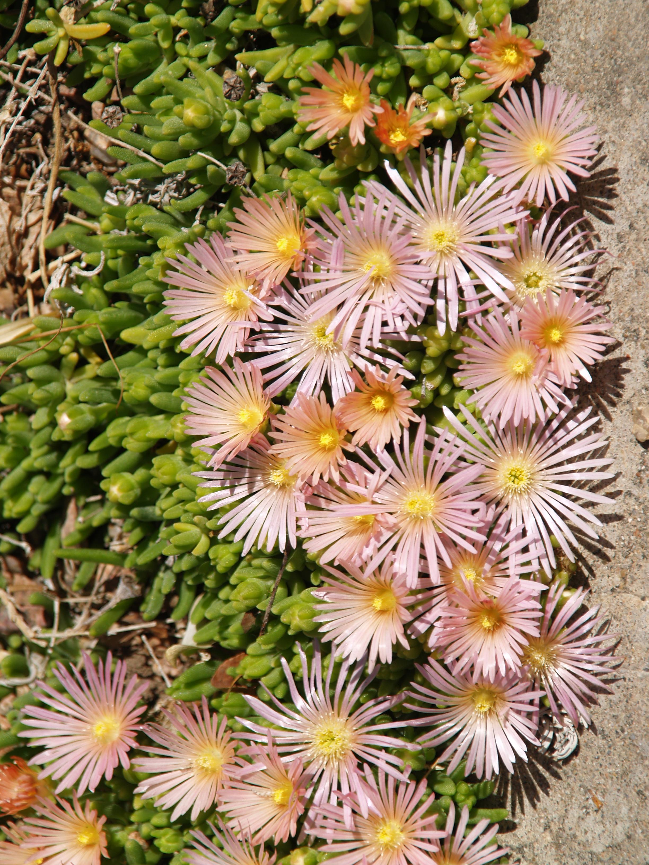
Height: 2”
Width: 12”
Blooms: Spring to fall
Sun: Full sun to partial shade
Water: Moderate
Hardiness: USDA zones 4b-8
Culture: Garden loam, clay, or gravelly soil
Introduced: 2002
Perennial
This iridescent, salmon-pink flowered sport appeared among plants of a dwarf, alpine form of Delospermum cooperi at Denver Botanic Gardens in 1997. It is vigorous, compact and floriferous.

Mesa Verde® Ice Plant
Delosperma ‘Kelaidis’ ^{PP13,876}
www.plantselect.org

