

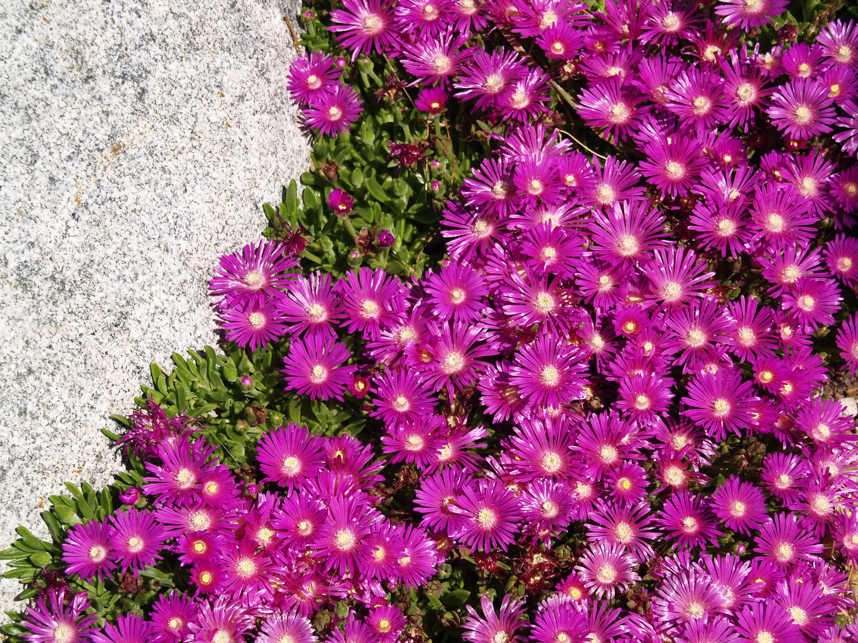
Height: 2”
Width: 18”
Blooms: Spring to fall
Sun: Full sun to partial shade
Water: Moderate
Hardiness: USDA zones 4-9
Culture: Garden loam, clay, or sandy soil
Introduced: 2002
Perennial
A fast spreading ground cover from South Africa that blooms for most of the growing season. The lustrous, fuchsia flowers are an improvement on Delosperma cooperi. During the winter the leaves remain turgid and green, often tinged with purple.

Table Mountain® Ice Plant
Delosperma ‘John Proffitt’
www.plantselect.org

