

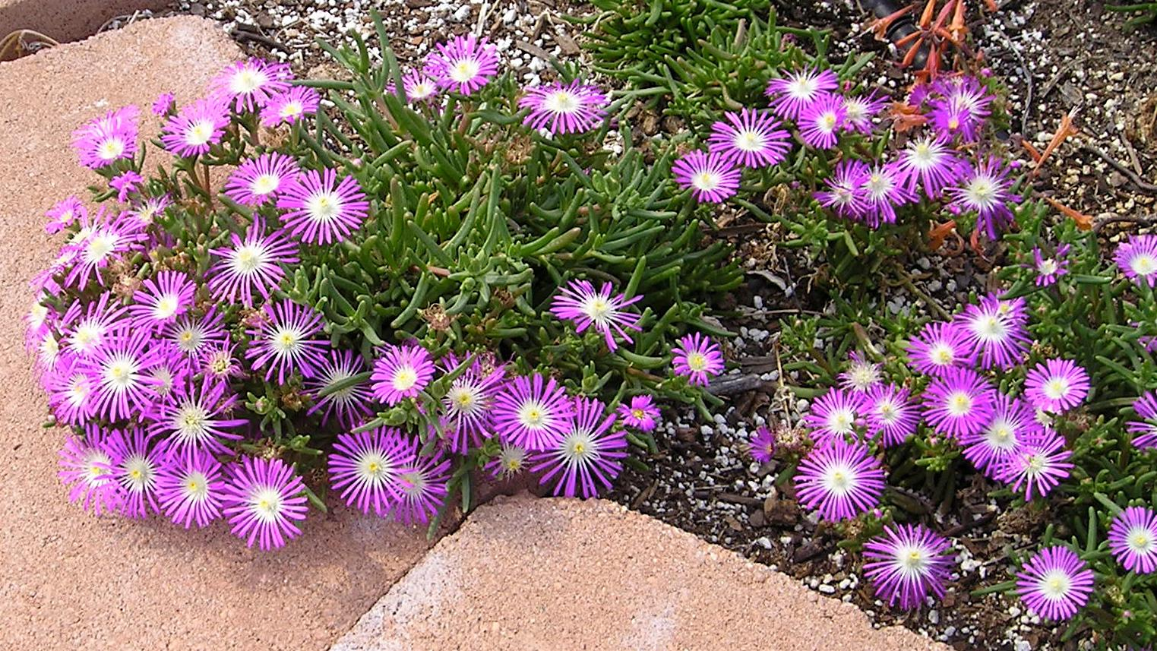
Height: 4”
Width: 10”
Blooms: June to frost
Sun: Full sun
Water: Moderate to dry; not too wet
Hardiness: USDA zones 4a-9
Culture: Ordinary soil
Introduced: 1998
Perennial groundcover
This clumping ice plant produces a dome of bright pink flowers with white centers. The texture of the petals is shimmering – almost like metal. It starts blooming in June, and continues until fall. Like the purple and yellow ice plants, it promises to be an essential small scale groundcover or edging for the border.

Starburst® Ice Plant
Delospermum floribundum
www.plantselect.org

