

**Fire Spinner® Ice Plant**

*Delosperma* ‘P001S’

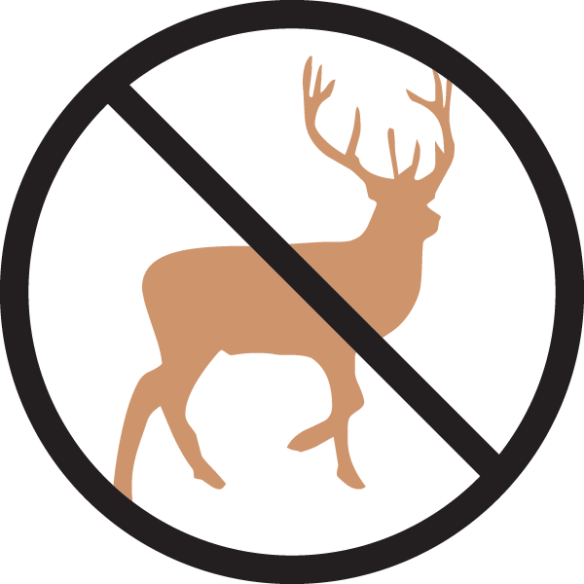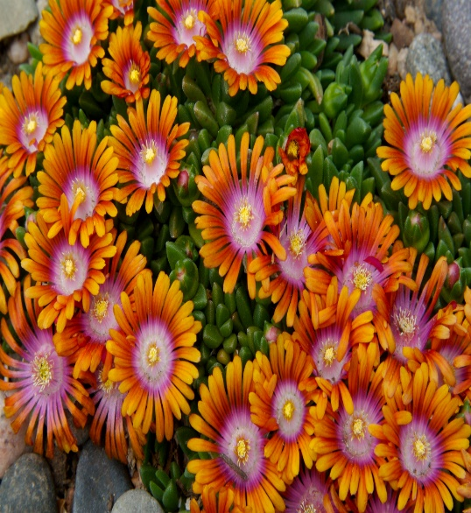

**Height: 2 in. Width: 14-18 in.**

This shocking color combination of the individual flowers represents a dramatic color breakthrough for the hardy ice plants. The green-apple foliage makes a glistening, fast spreading carpet that keeps its shiny presence through winter.

**Culture:** Sandy loam soil

**Hardiness:** USDA zones 5-10



WIND. HAIL. SNOW. SUN

**BRING IT ON**

www.plantselect.org

