

**Red Mountain® Ice Plant**

*Delosperma dyeri ‘*Psdold’

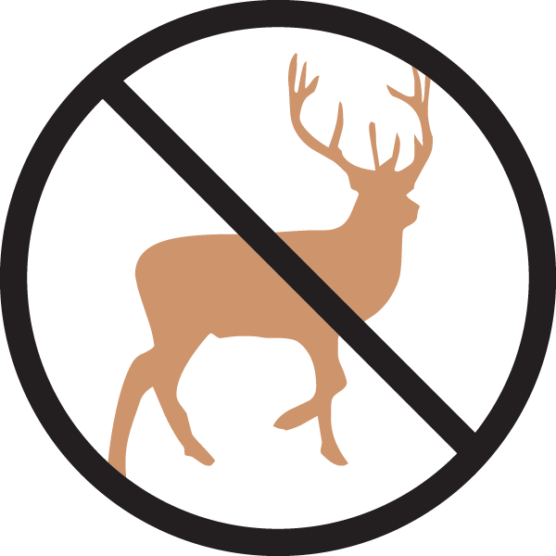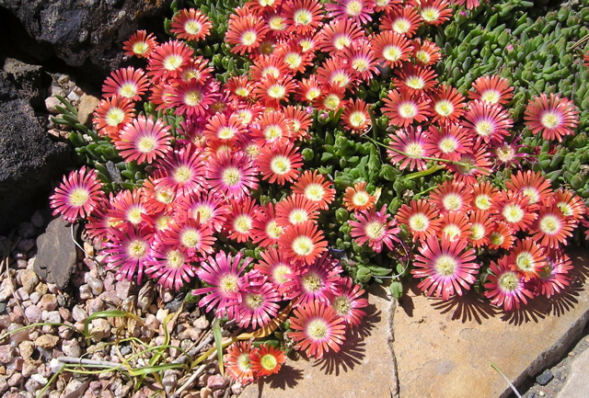

**Height: 2 in. Width: 14-18 in.**

Glowing burnished red carpet of flowers from April to early summer, with some flushes of bloom all season long. Trim, succulent South African hardy ice plant.

**Culture:** Clay, loam or sandy soil

**Hardiness:** USDA zones 5-8



WIND. HAIL. SNOW. SUN

**BRING IT ON**

www.plantselect.org

