

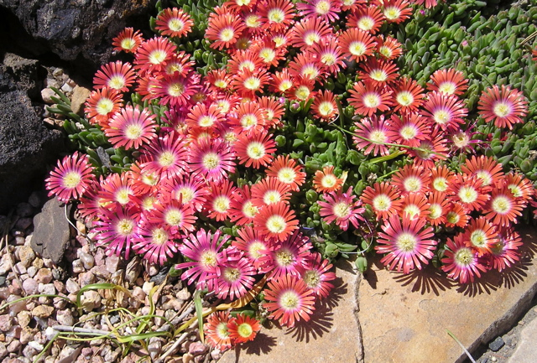
Height: 2”
Width: 15-20”
Blooms: April to September
Sun: Full sun to partial shade
Water: Moderate to xeric (once established)
Hardiness: USDA zones 5-8 (up to 6,000’)
Culture: Clay, loam or sandy soil
Introduced: 2007
Perennial
Glowing burnished red carpet of flowers span the growing season. Trim, succulent ice plant.

Red Mountain® Ice Plant
Delosperma dyeri ‘Psdold’
www.plantselect.org

