

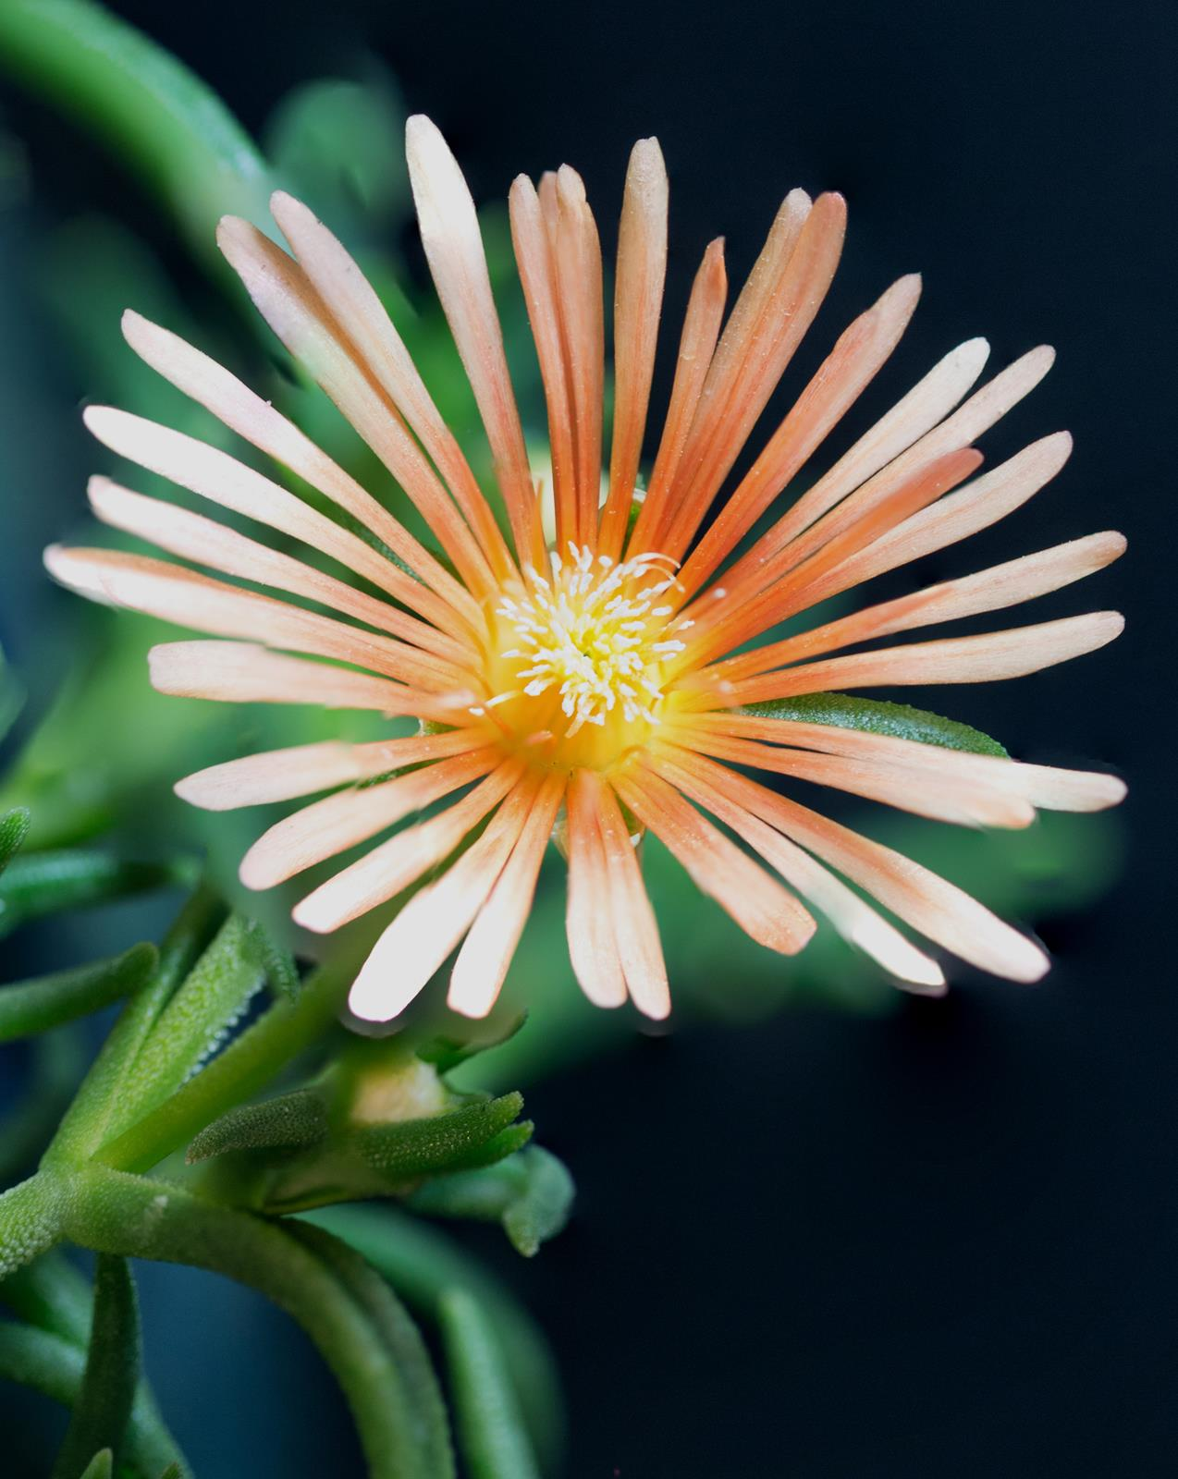






Height: 1-2”
Width: 12-18”
Blooms: Late spring through fall
Sun: Full sun to partial shade
Water: Moderate to xeric
Hardiness: USDA zones 4-9
Culture: Adaptable
Introduced: 2016
Perennial groundcover
Hardy ice plants have been part of water-smart landscapes for many years, but this new softly-hued form offers color nearly all summer long. In trials at Colorado State University, Alan’s Apricot proved to be longer-blooming and more adaptable then some of the other delospermas. From Alan Tower of Tower Nursery, Spokane, WA.

Alan’s Apricot ice plant
Delosperma ‘Alan’s Apricot’ ^{PPAF}
www.plantselect.org

