
Alan’s Apricot ice plant
Delosperma ‘Alan’s Apricot’ ^{PPAF}

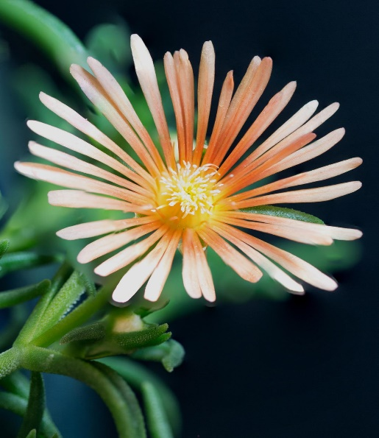








Height: 1-2 in. Width: 12-18 in.
Hardy ice plants have been part of water-smart landscapes for many years, but this new softly-hued form offers color nearly all summer long. From Alan Tower of Tower Nursery, Spokane, WA.
Culture: Adaptable
Hardiness: USDA zones 4-9



WIND. HAIL. SNOW. SUN
BRING IT ON

www.plantselect.org



