

**Alan’s Apricot ice plant**

*Delosperma ‘Alan’s Apricot’* PPAF

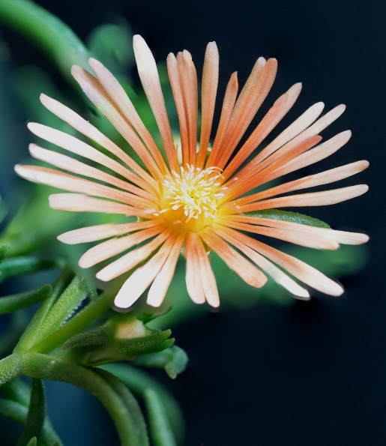

**Height: 1-2 in. Width: 12-18 in.**

Hardy ice plants have been part of water-smart landscapes for many years, but this new softly-hued form offers color nearly all summer long. From Alan Tower of Tower Nursery, Spokane, WA.

**Culture:** Adaptable

**Hardiness:** USDA zones 4-9



WIND. HAIL. SNOW. SUN

**BRING IT ON**

www.plantselect.org

