

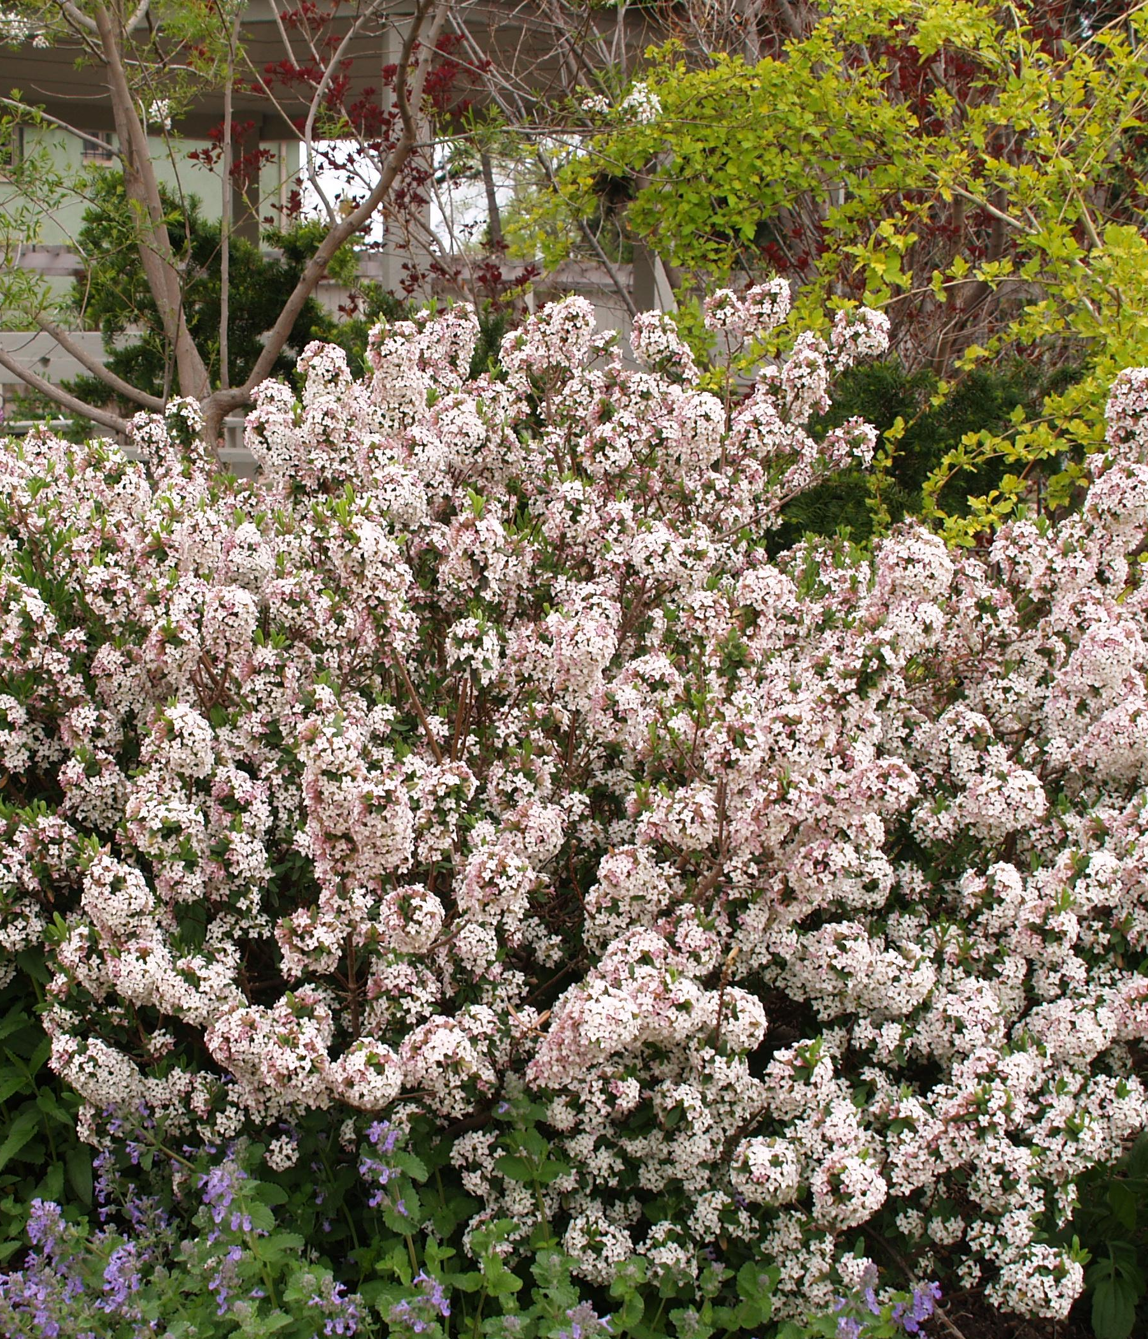
Height: 4’
Width: 4’
Blooms: Early to mid-spring
Sun: Full sun to partial shade
Water: Needs average water
Hardiness: USDA zones 4a-9
Culture: Garden loam
Introduced: 1997
Shrub
This trim, aristocratic shrub has whorls of nearly evergreen, cream-edged foliage. It produces a heavy display of very fragrant, pale pink flowers in spring, and often again in the fall. It is adaptable and quick growing.

Carol Mackie Daphne
Daphne x burkwoodii ‘Carol Mackie’
www.plantselect.org

