
Carol Mackie Daphne
Daphne x burkwoodii ‘Carol Mackie’

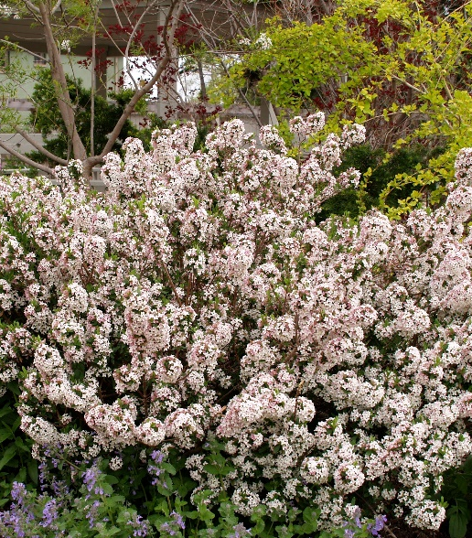





Height: 4 ft. Width: 4 ft.
This trim, aristocratic shrub has whorls of nearly evergreen, cream-edged foliage. It produces a heavy display of very fragrant, pale pink flowers in spring, and often again in the fall. It is adaptable and quick growing.
Culture: Garden loam
Hardiness: USDA zones 4-9



WIND. HAIL. SNOW. SUN
BRING IT ON

www.plantselect.org



