

**Carol Mackie Daphne**

*Daphne x burkwoodii* ‘Carol Mackie’

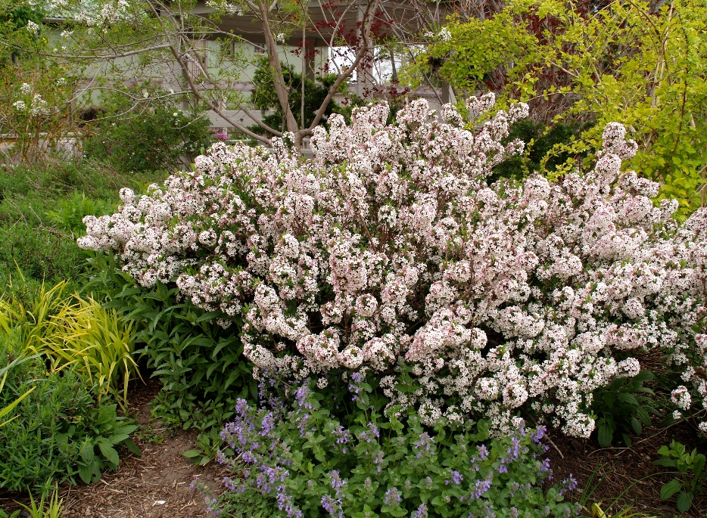

**Height: 4 ft. Width: 4 ft.**

This trim, aristocratic shrub has whorls of nearly evergreen, cream-edged foliage. It produces a heavy display of very fragrant, pale pink flowers in spring, and often again in the fall. It is adaptable and quick growing.

**Culture:** Garden loam

**Hardiness:** USDA zones 4-9



WIND. HAIL. SNOW. SUN

**BRING IT ON**

www.plantselect.org

