


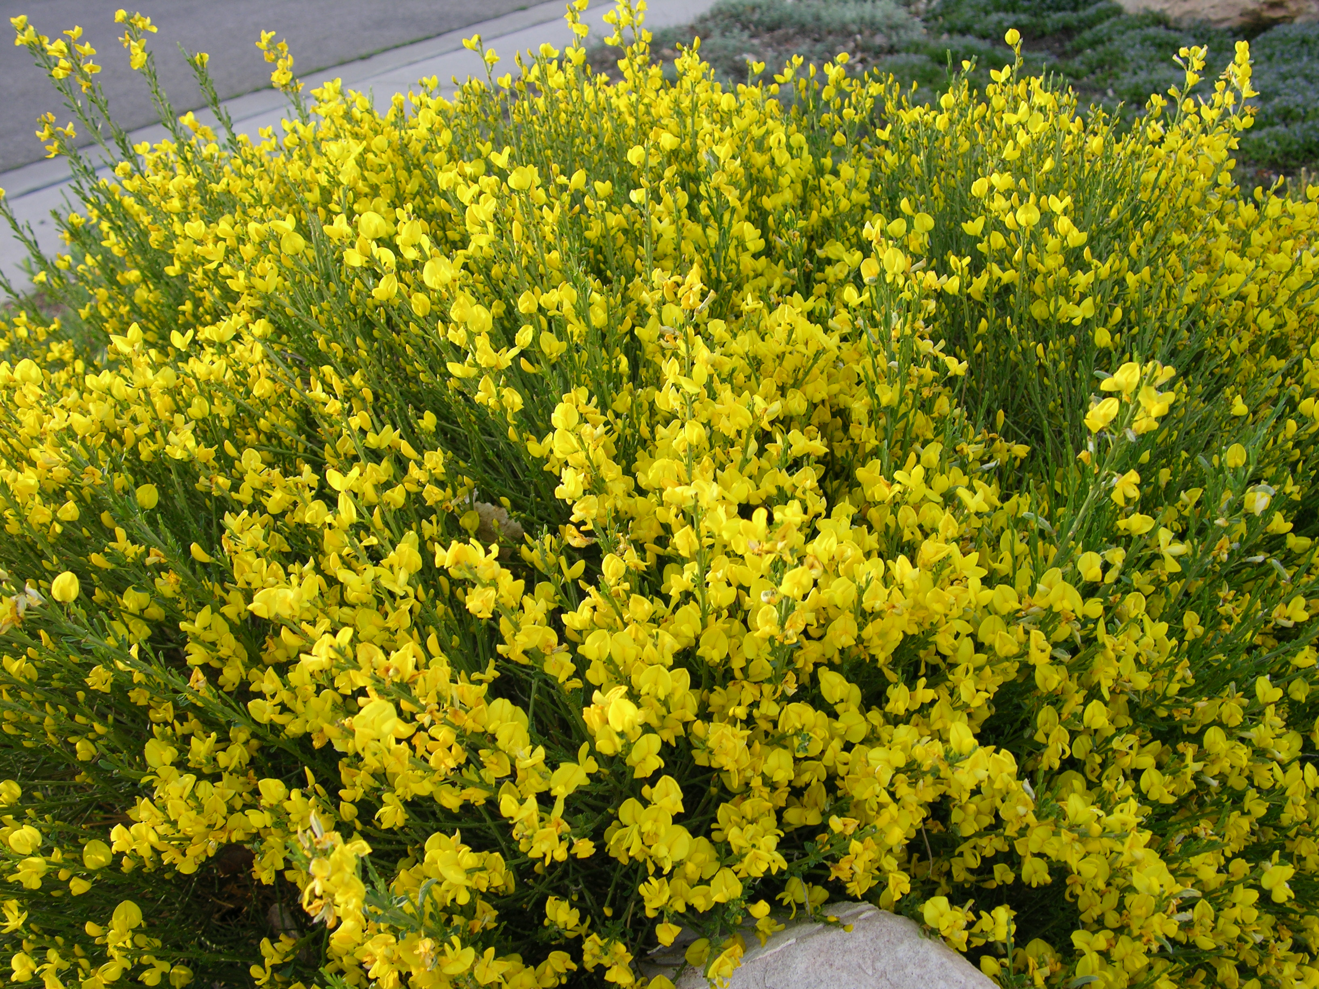
Height: 4’
Width: 6’
Blooms: Mid to late spring
Sun: Full sun to partial shade
Water: Moderate; not too wet
Hardiness: USDA zones 4a-9
Culture: Average, clay loam, or gravelly soil
Introduced: 2000
Shrub
A dense mound of ascending bright green stems spangled for much of the spring with golden, pea blossoms. This subalpine shrub from the mountains of Spain has shown much greater hardiness than other large brooms and tolerates a wide range of soil and moisture conditions. Its rounded form and vivid blooms are outstanding.

Spanish Gold® Broom
Cytisus purgans
www.plantselect.org

