

**Spanish Gold® Broom**

*Cytisus purgans*

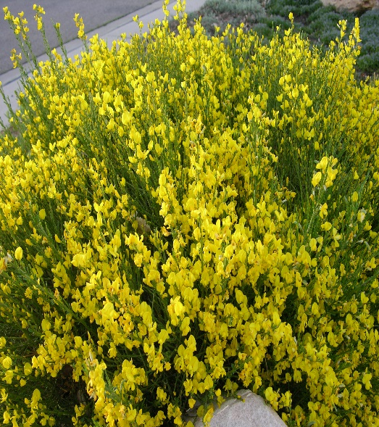

**Height: 4 ft. Width: 6 ft.**

A dense mound of bright, ever-green stems spangled for much of the spring with golden, pea blossoms. This subalpine shrub from the mountains of Spain has shown much greater hardiness than other large brooms. Its rounded form and vivid blooms are outstanding.

**Culture:** Average, clay loam or gravelly soil

**Hardiness:** USDA zones 4-9



WIND. HAIL. SNOW. SUN

**BRING IT ON**

www.plantselect.org

