

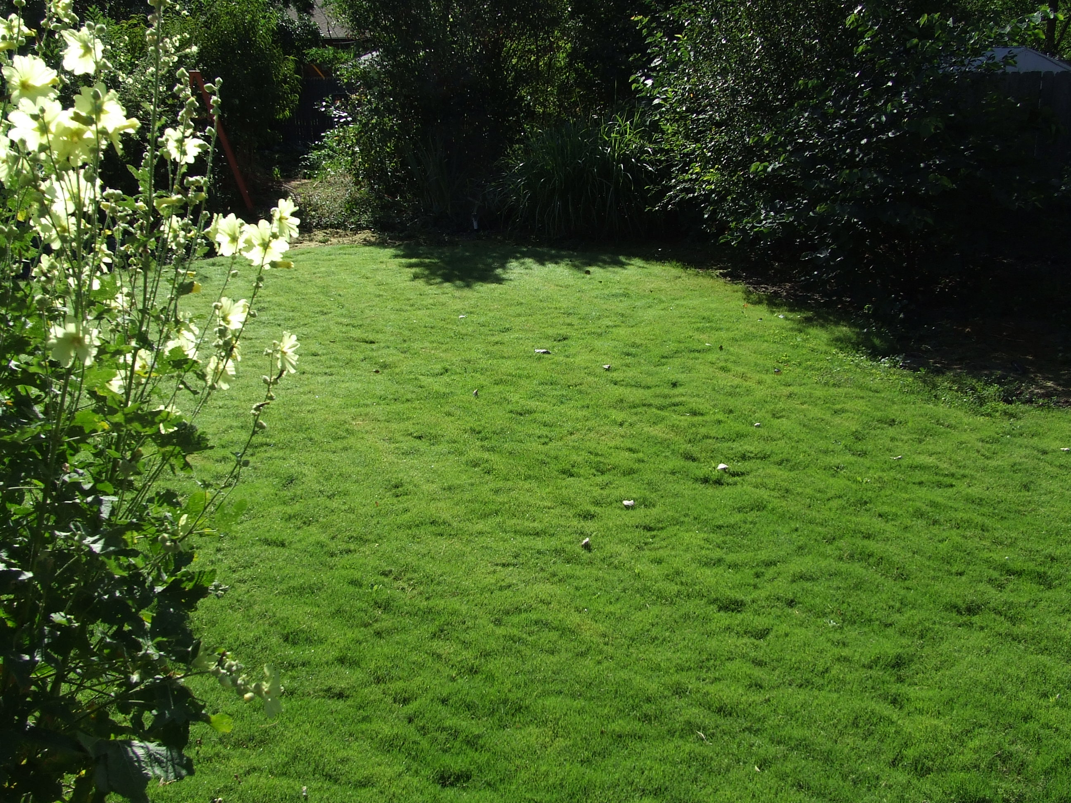



Height: 2.5 - 4”
Width: 2+ ft
Sun: Full sun
Water: Dryto xeric
Hardiness: USDA zones 5-10
Culture: Adaptable
Introduced: 2016
Turf Grass
Looking for a xeric alternative lawn grass? Try Dog Tuff™, a sterile hybrid that spreads via runners. Similar to American buffalo grass but more resilient to wear and tear and named for its exceptional durability with dogs. Once established it’s highly weed-resistant. A warm-season grass Dog Tuff™ turns green in late spring and goes dormant with frost. Find detailed instructions for planting and establishing: tinyurl.com/dogtufflearn.

Dog Tuff™ grass
Cynodon ‘PWIN04S’
www.plantselect.org

