

**Dog Tuff™ grass**

*Cynodon ‘*PWIN04S

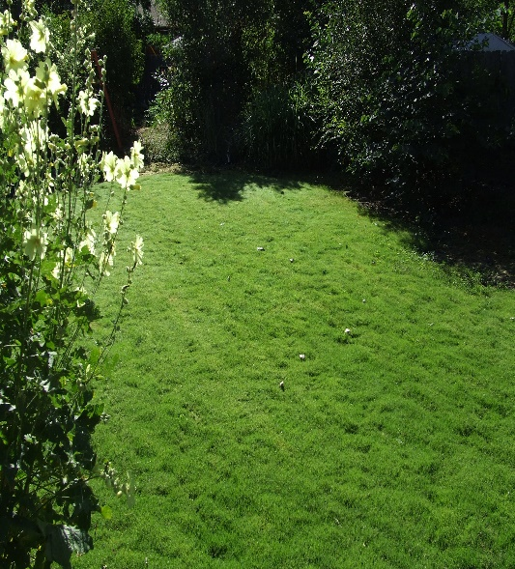

**Height: 2.5- 4 in. Width: 2+ ft.**

Looking for a xeric alternative lawn grass? Try Dog Tuff™, a sterile hybrid that spreads via runners. Similar to American buffalo grass but more resilient to wear and tear. Highly weed-resistant once established. Goes dormant with frost.

**Culture:** Adaptable

**Hardiness:** USDA zones 5-10



WIND. HAIL. SNOW. SUN

**BRING IT ON**

www.plantselect.org

