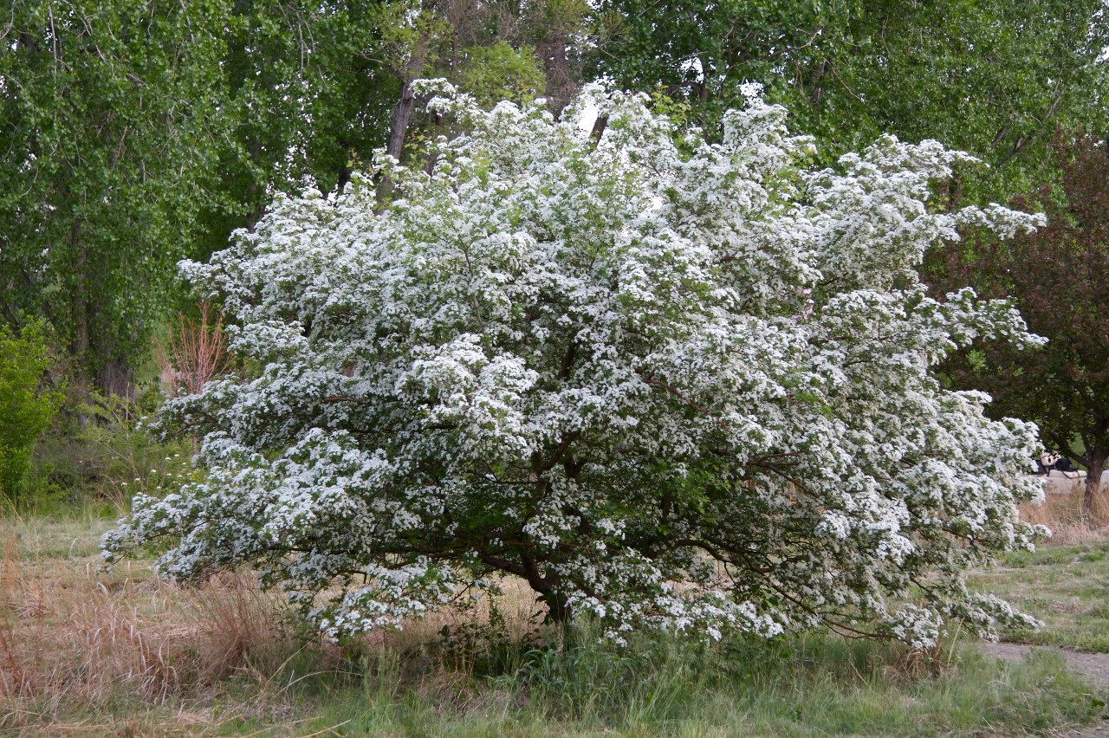
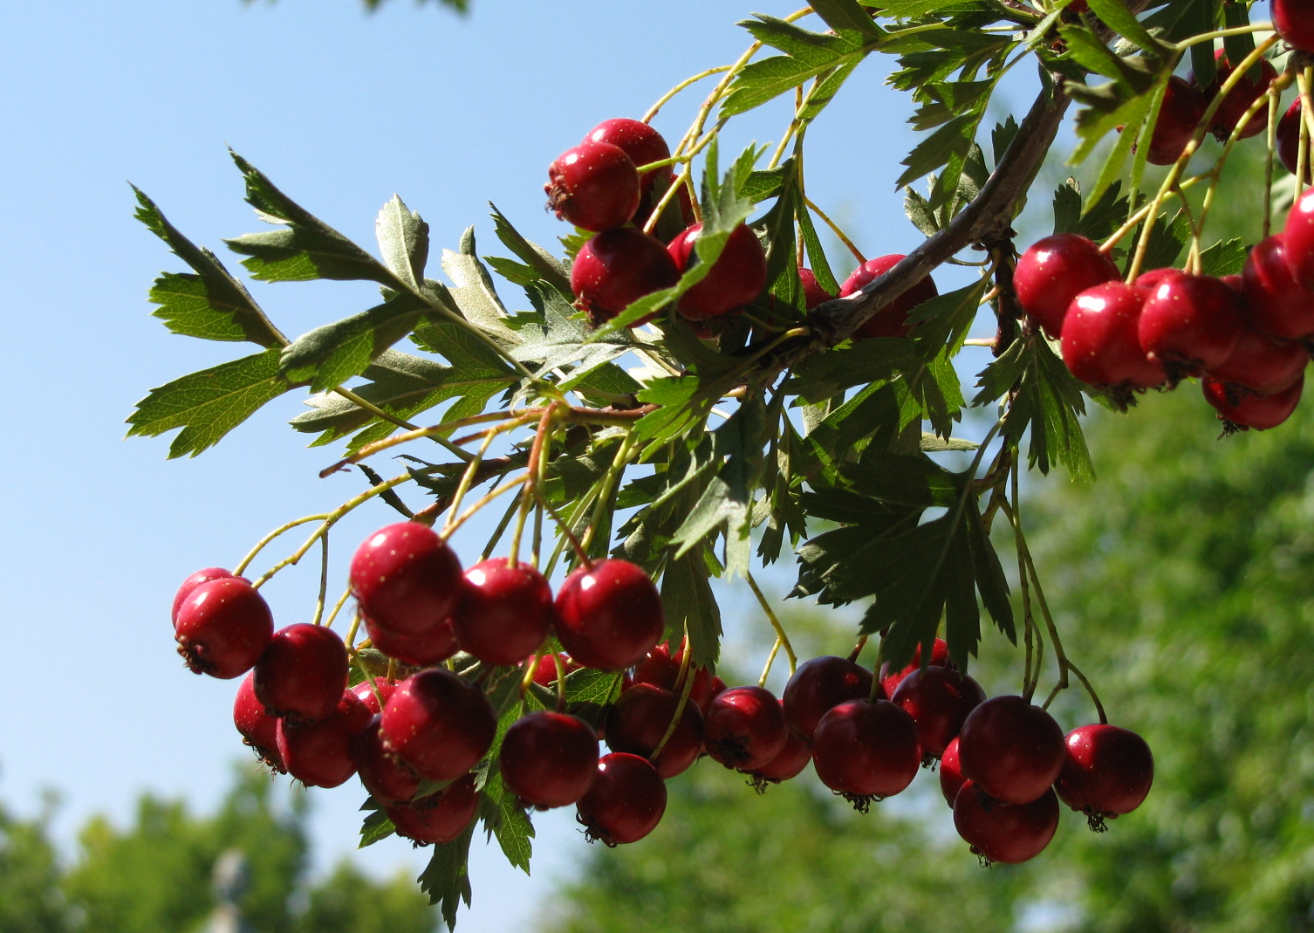

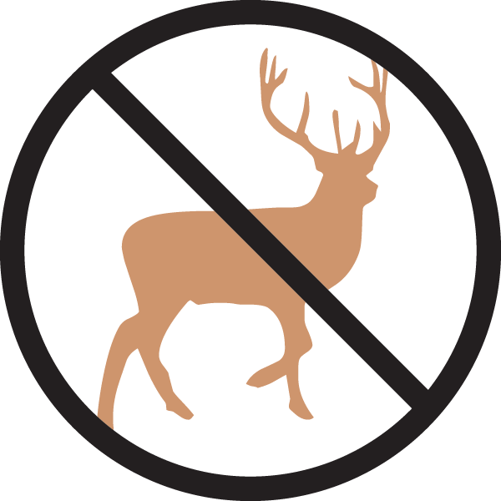


Height: 12-24’
Width: 6-12’
Blooms: April to May
Sun: Full sun to partial shade
Water: Moderate to xeric
Hardiness: USDA zones 4-9 (up to 8,000’)
Culture: Clay, loam, or sandy soils
Introduced: 2011
Small Tree
Another gem tracing its origins in American horticulture to the Cheyenne Experiment Station, this nearly perfect small tree has gorgeous bark, foliage and flowers followed by glistening red fruit in fall beloved of birds. Did we mention golden fall color? An underutilized tree, although treasured by keen gardeners in the Front Range.

Russian Hawthorn
Crataegus ambigua
www.plantselect.org

