

**Russian Hawthorn**

*Crataegus ambigua*

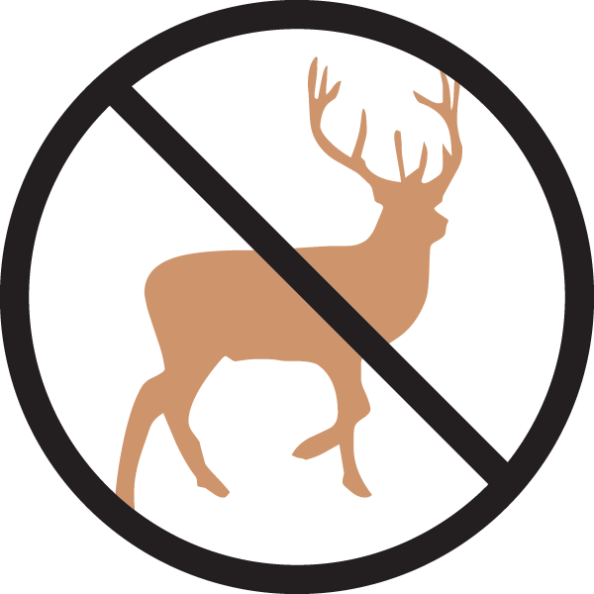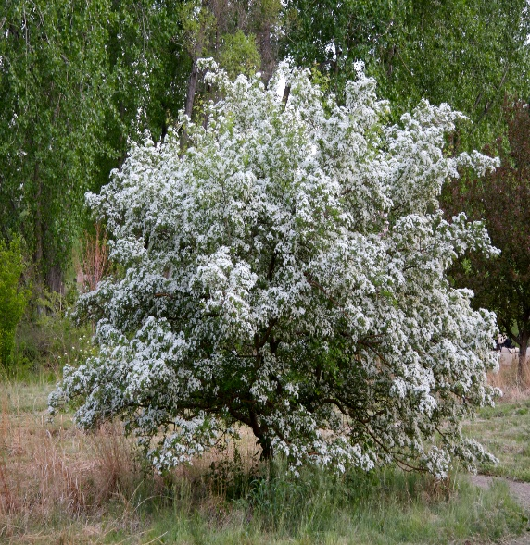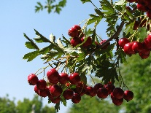

**Height: 16-20 ft. Width: 12-16 ft.**

Another gem tracing its origins to the Cheyenne Experiment Station, this nearly perfect small tree has gorgeous bark, foliage and flowers followed by glistening red fruit in fall beloved of birds. Did we mention golden fall color?

**Culture:** Clay, loam, or sandy soils

**Hardiness:** USDA zones 4-9



WIND. HAIL. SNOW. SUN

**BRING IT ON**

www.plantselect.org

