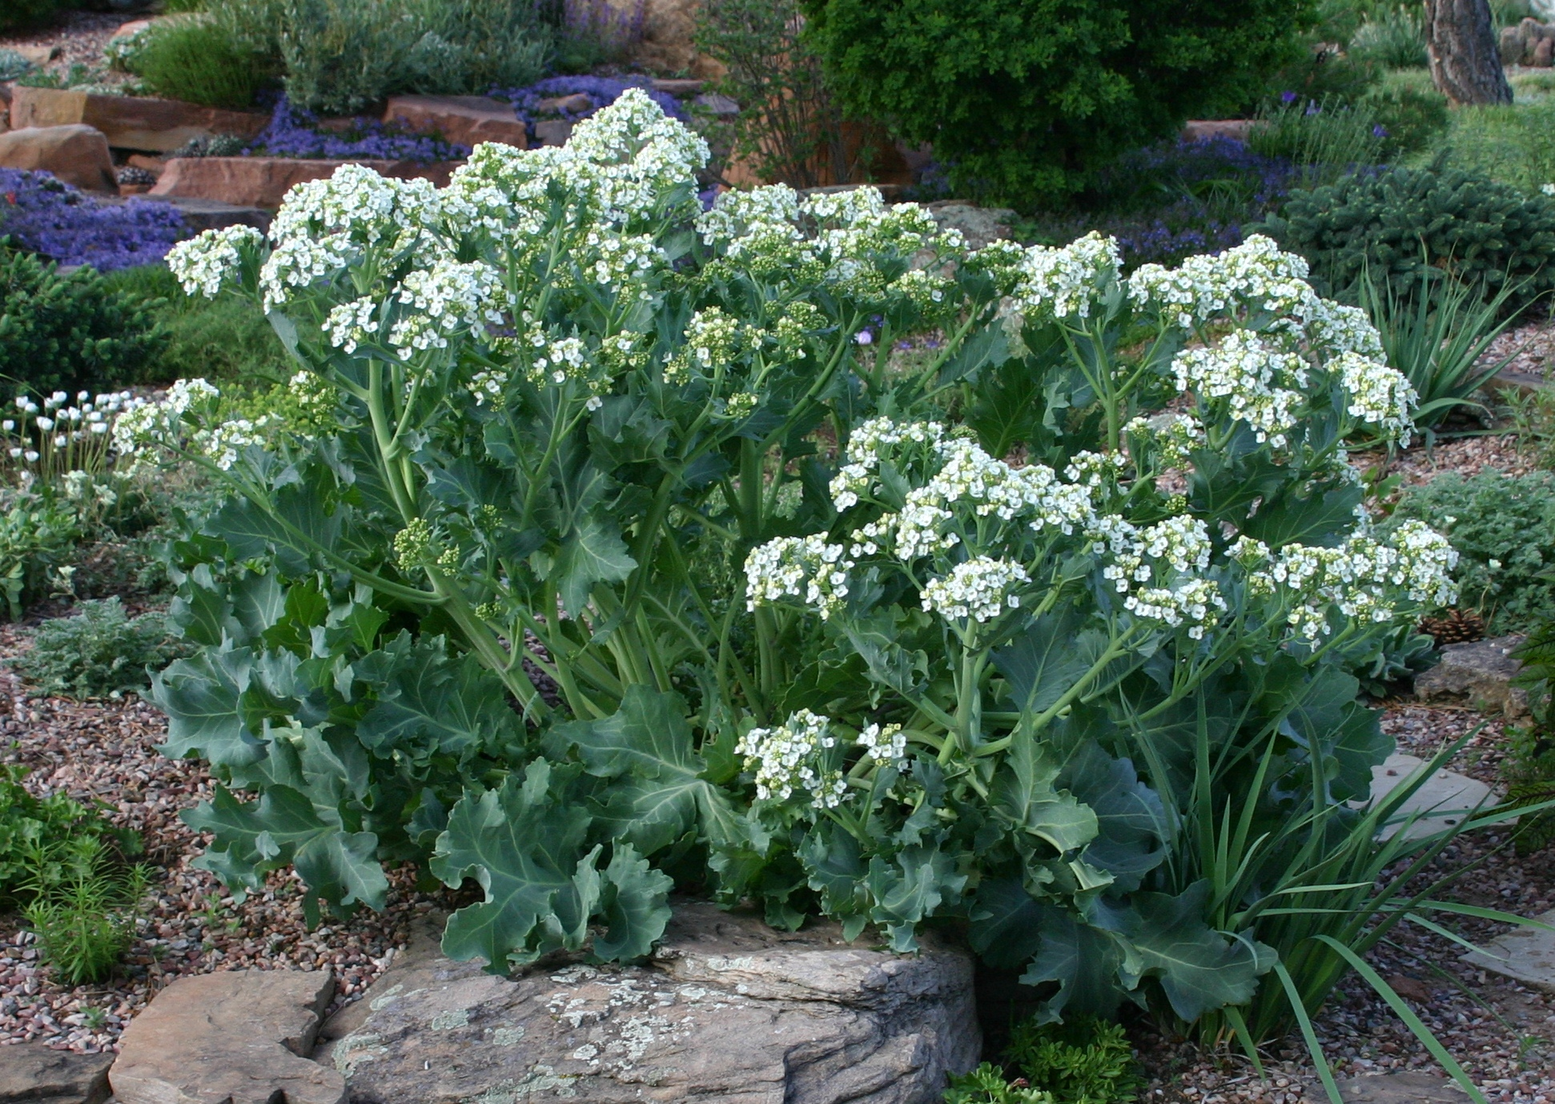



Height: 24”
Width: 24-30”
Blooms: May to June
Sun: Full sun
Water: Moderate to dry
Hardiness: USDA zones 4-8
Culture: Sandy, clay, or loam soil
Introduced: 2013
Perennial
This robust, traditional European perennial potherb forms impressive clumps of gorgeous, wavy, waxy blue foliage all summer long. In spring, clusters of dazzling white flowers grace the garden. Tough and permanent once established, this beautiful perennial offers larger-scale, summer-long interest for dry gardens.

Curly Leaf Sea Kale
Crambe maritima
www.plantselect.org

