
Curly Leaf Sea Kale
Crambe maritima

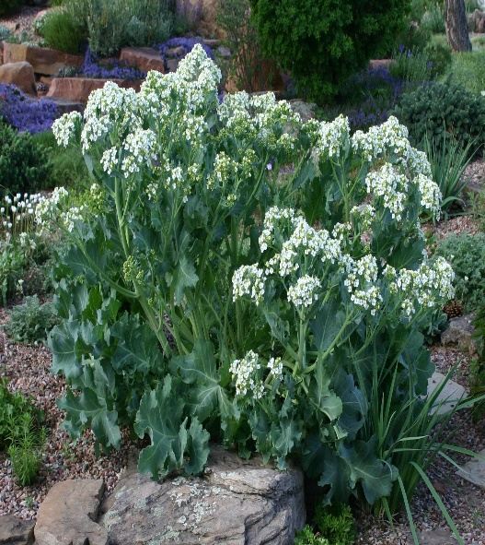






Height: 24 in. Width: 24-30 in.
This traditional European perennial potherb forms large clumps of wavy, waxy blue foliage. Clusters of white flowers in early summer. Tough and permanent once established, this beautiful perennial offers larger-scale, summer-long interest for dry gardens.
Culture: Sandy, clay, or loam soil
Hardiness: USDA zones 4-8



WIND. HAIL. SNOW. SUN
BRING IT ON

www.plantselect.org



