

**Curly Leaf Sea Kale**

*Crambe maritima*

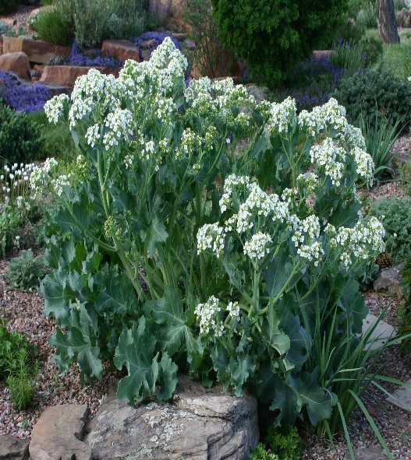

**Height: 24 in. Width: 24-30 in.**

This traditional European perennial potherb forms large clumps of wavy, waxy blue foliage. Clusters of white flowers in early summer. Tough and permanent once established, this beautiful perennial offers larger-scale, summer-long interest for dry gardens.

**Culture:** Sandy, clay, or loam soil

**Hardiness:** USDA zones 4-8



WIND. HAIL. SNOW. SUN

**BRING IT ON**

www.plantselect.org

