
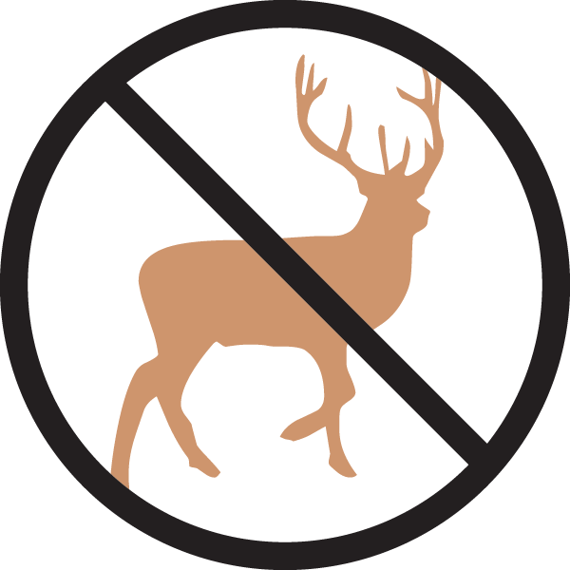


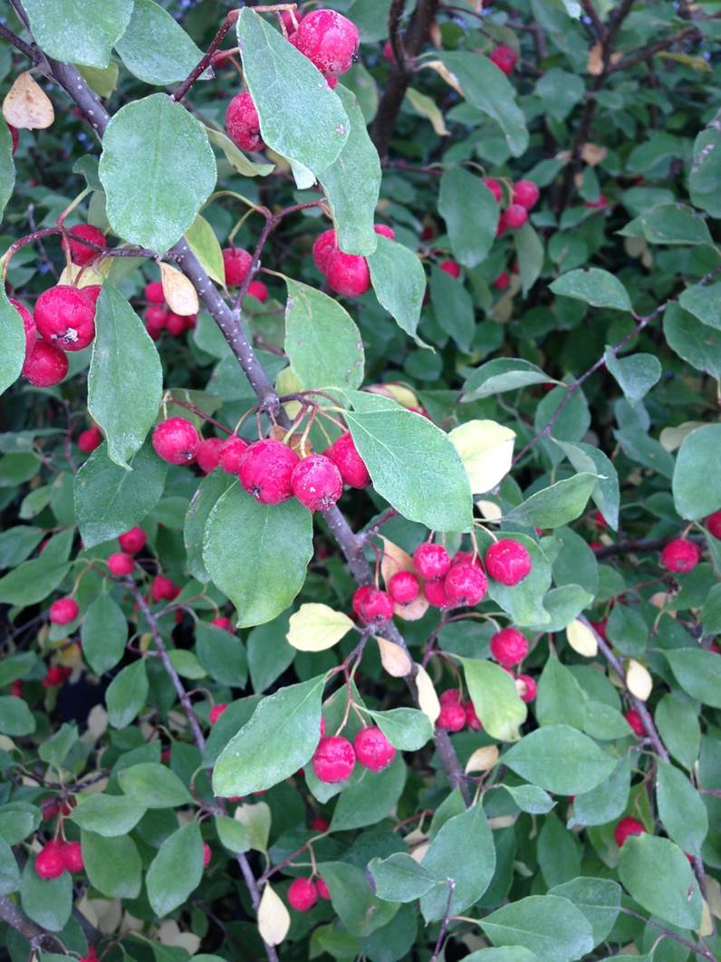
Height: 6-8’
Width: 6-8’
Blooms: Late spring
Sun: Full sun to partial shade
Water: Moderate to xeric
Hardiness: USDA zones 3-8
Culture: Clay, loam or sandy soil
Introduced: 2017
Shrub
A gracefully arching larger shrub with dark green leaves above and gray-white beneath. Abundant red fruit in early fall. Thought to be one of the hardiest of all the cotoneasters, this shrub is resistant to most pests and diseases.

Sungari redbead cotoneaster
Cotoneaster racemiflorus var. soongoricus
www.plantselect.org

