

**Sungari Redbead Cotoneaster**

*Cotoneaster racemiflorus var. soongoricus*

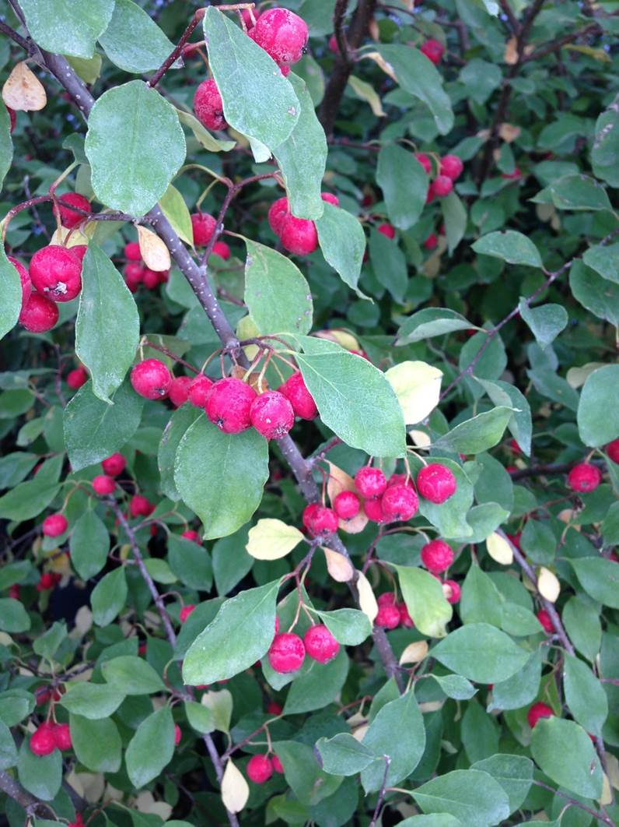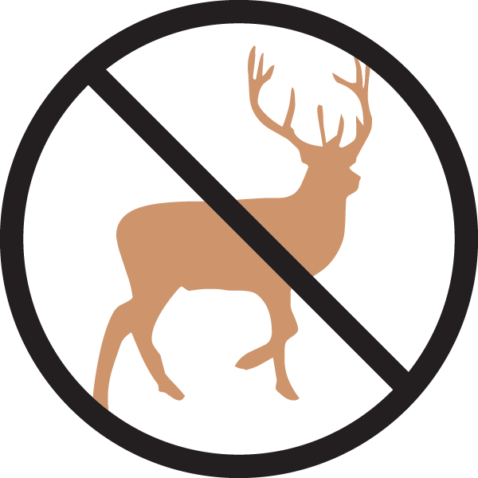

**Height: 6-8 ft. Width: 6-8 ft.**

A gracefully arching larger shrub with dark green leaves above and gray-white beneath. Abundant red fruit in early fall. Thought to be one of the hardiest of all the cotoneasters, this shrub is resistant to most pests and diseases.

**Culture:** Clay, loam or sandy soil

**Hardiness:** USDA zones 3-8



WIND. HAIL. SNOW. SUN

**BRING IT ON**

www.plantselect.org

