
Mongolian Bells® Clematis
Clematis integrifolia ‘PsHarlan’

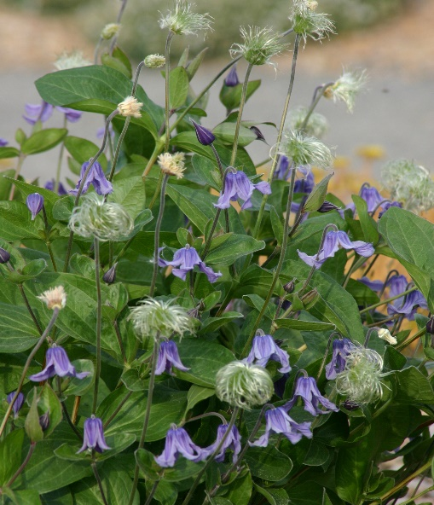






Height: 10-14 in. Width: 12-15 in.
Introduced from Mongolia by Harlan Hamernik of Bluebird Nursery, this is a very common herbaceous species. Available in a spectrum of colors (including pink, white, lavender and blue), it makes the perfect edging or mounding clump in a border or xeriscape. Attractive seed heads in late summer and fall.
Culture: Sandy loam or loam
Hardiness: USDA zones 3-9



WIND. HAIL. SNOW. SUN
BRING IT ON

www.plantselect.org



