

**Mongolian Bells® Clematis**

*Clematis integrifolia* ‘PsHarlan’

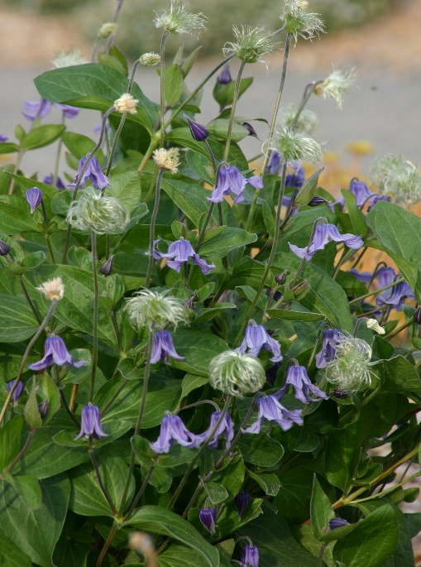

**Height: 10-14 in. Width: 12-15 in.**

Introduced from Mongolia by Harlan Hamernik of Bluebird Nursery, this is a very common herbaceous species. Available in a spectrum of colors (including pink, white, lavender and blue), it makes the perfect edging or mounding clump in a border or xeriscape. Attractive seed heads in late summer and fall.

**Culture:** Sandy loam or loam

**Hardiness:** USDA zones 3-9



WIND. HAIL. SNOW. SUN

**BRING IT ON**

www.plantselect.org

