


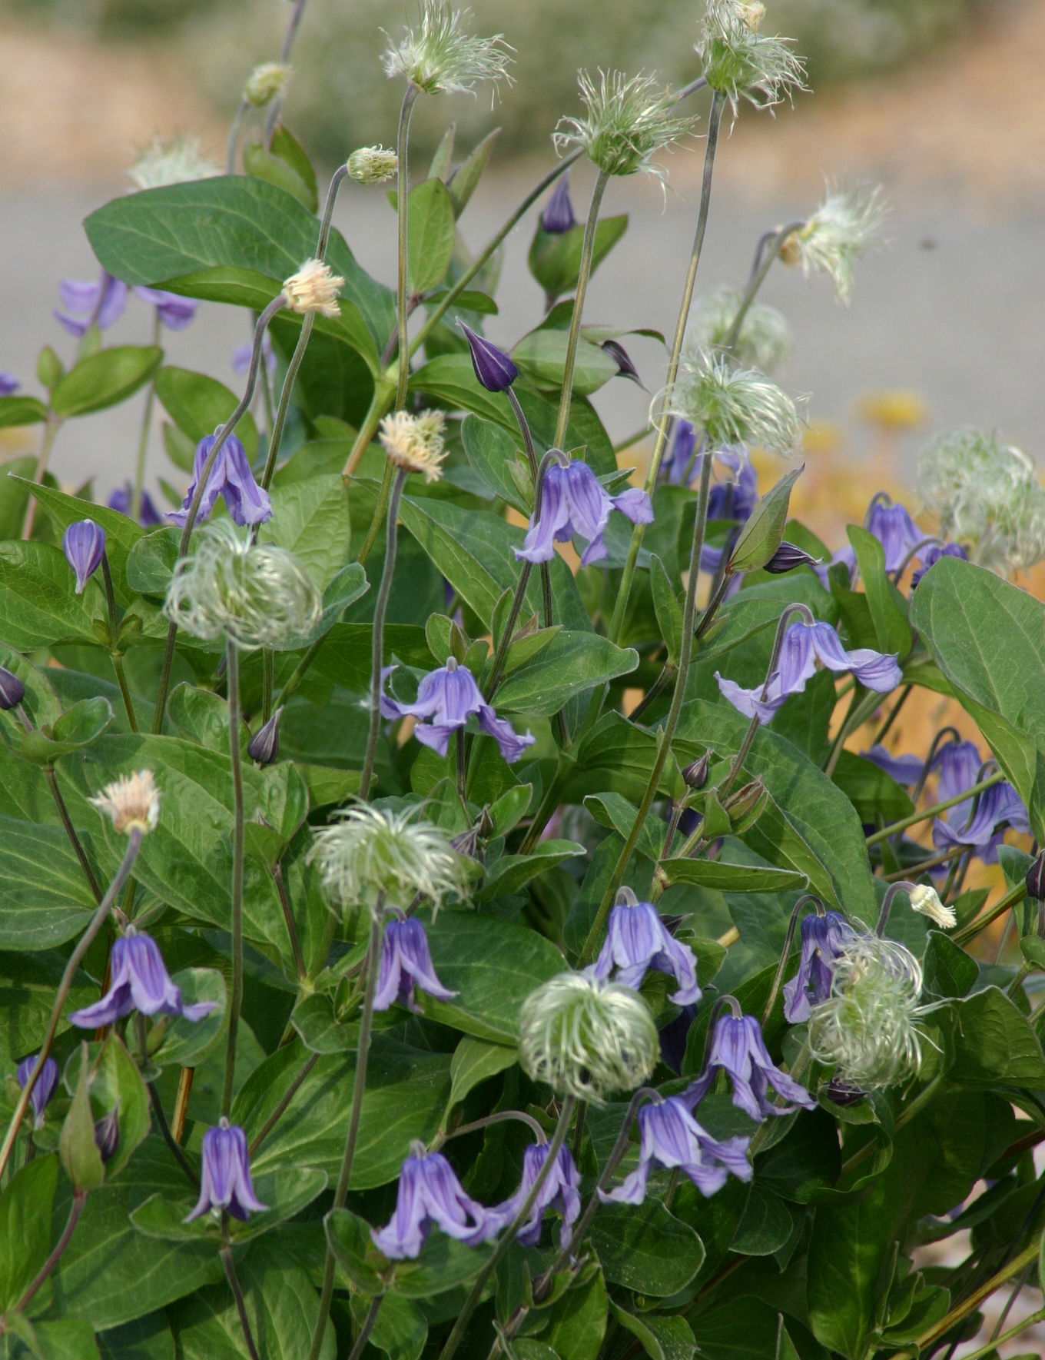
Height: 10-14”
Width: 12-15”
Blooms: May to September
Sun: Full sun to partial shade
Water: Moderate to dry
Hardiness: USDA zones 3-9 (up to 10,000’)
Culture: Sandy loam or loam
Recommended: 2008
Perennial
Introduced from Mongolia by Harlan Hamernik of Bluebird Nursery, this is a very compact form of the common herbaceous species. Available in a spectrum of colors (including pink, white, lavender and blue), it makes the perfect edging or mounding clump in a border or xeriscape. Attractive seed heads in late summer and fall.

Mongolian Bells® Clematis
Clematis integrifolia ‘PsHarlan’
www.plantselect.org

