
Mongolian Snowflakes
Clematis hexapetala

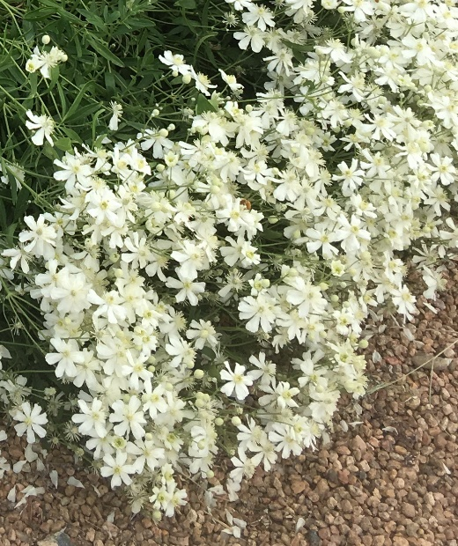







Height: 2-3 ft. Width: 2-3 ft.
A low growing clematis forming a mounded snowstorm of 2 inch, six-petaled ivory flowers that bloom May through summer. Spent flowers give way to feathery seed puffs that are showy above dark green foliage.
Culture: Clay, loam or sandy soil
Hardiness: USDA zones 5-9



WIND. HAIL. SNOW. SUN
BRING IT ON
www.plantselect.org

