

**Mongolian Snowflakes**

*Clematis hexapetala*

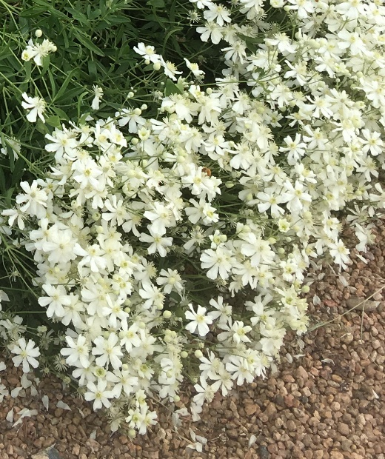

**Height: 2-3 ft. Width: 2-3 ft.**

A low growing clematis forming a mounded snowstorm of 2 inch, six-petaled ivory flowers that bloom May through summer. Spent flowers give way to feathery seed puffs that are showy above dark green foliage.

**Culture:** Clay, loam or sandy soil

**Hardiness:** USDA zones 5-9



WIND. HAIL. SNOW. SUN

**BRING IT ON**

www.plantselect.org