
Baby Blue Rabbitbrush
Chrysothamnus (Ericameria) nauseosus var. nauseosus





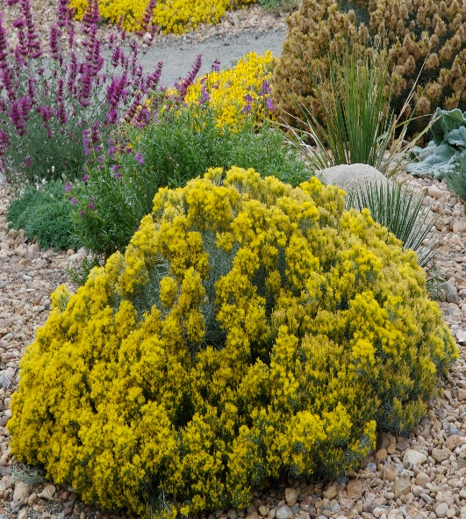



Height: 16-28 in. Width: 20-30 in.
This compact, dome-like strain of rabbitbrush found along the Front Range is especially dense and silvery-blue with bright golden flowers in late summer and fall. An indispensable and indestructible native with multi-season interest. Also known as “dwarf blue rabbitbrush.”
Culture: Clay, loam, or sandy soil
Hardiness: USDA zones 4-9



WIND. HAIL. SNOW. SUN
BRING IT ON

www.plantselect.org



