

**Baby Blue Rabbitbrush**

*Chrysothamnus (Ericameria) nauseosus* var. nauseosus

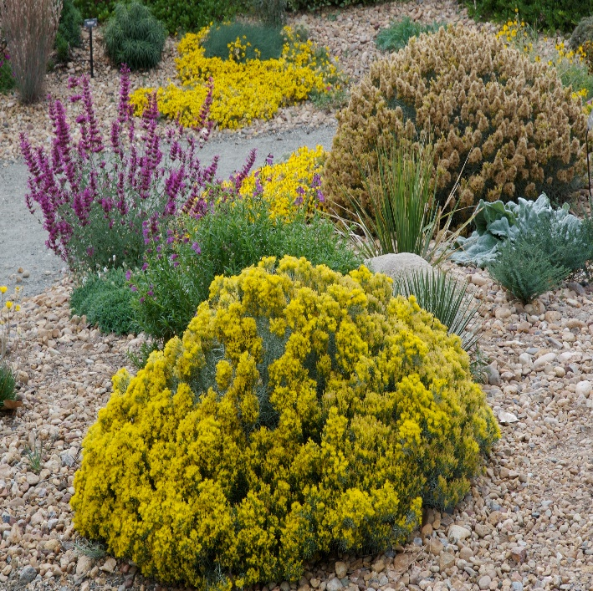

**Height: 16-28 in. Width: 20-30 in.**

This compact, dome-like strain of rabbitbrush found along the Front Range is especially dense and silvery-blue with bright golden flowers in late summer and fall. An indispensable and indestructible native with multi-season interest. Also known as “dwarf blue rabbitbrush.”

**Culture:** Clay, loam, or sandy soil

**Hardiness:** USDA zones 4-9



WIND. HAIL. SNOW. SUN

**BRING IT ON**

www.plantselect.org

