



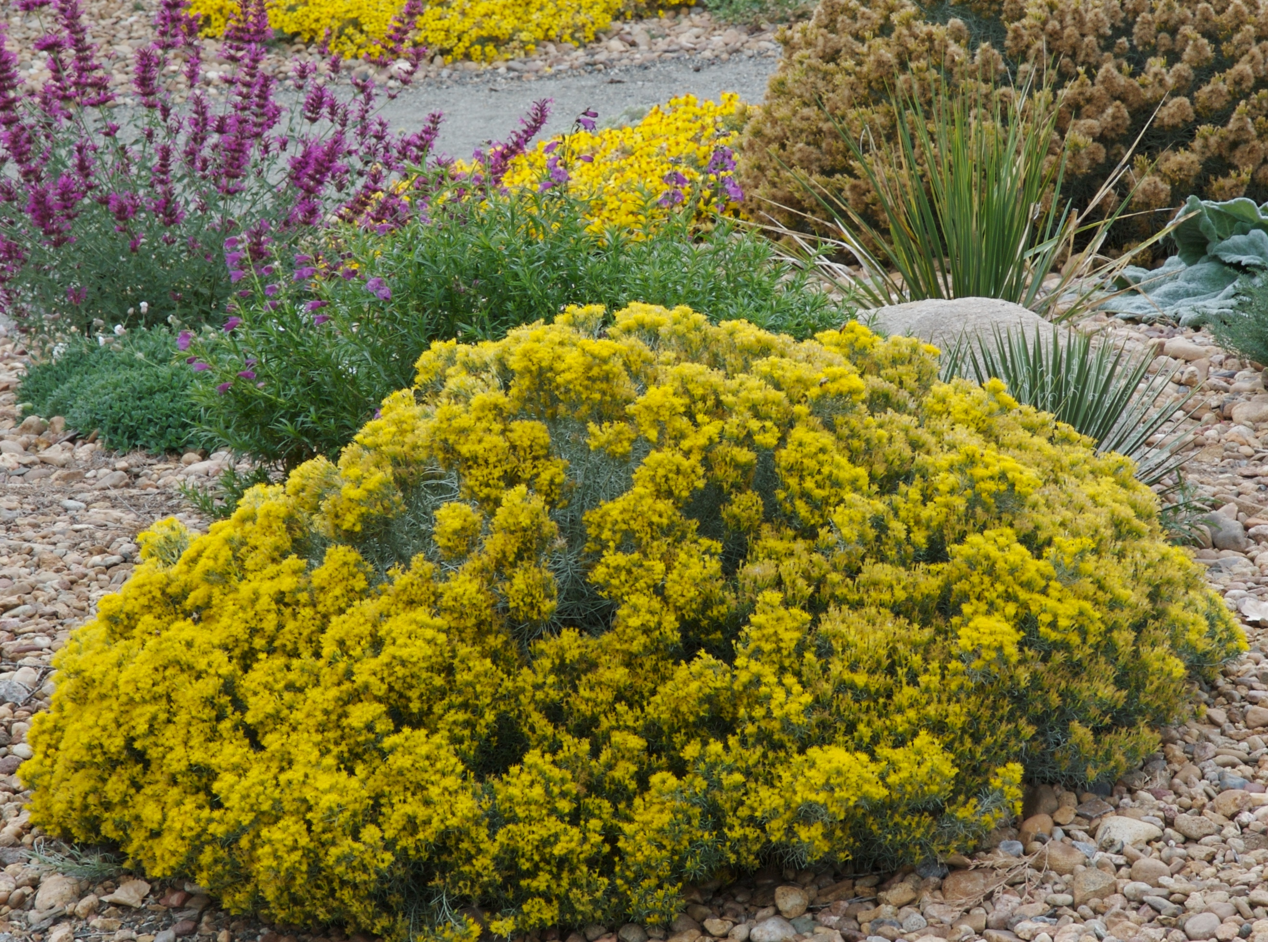
Height: 16-28”
Width: 20-30”
Blooms: September to November
Sun: Full sun to partial shade
Water: Moderate to xeric
Hardiness: USDA zones 4-9 (up to 8,000’)
Culture: Clay, loam, or sandy soils
Introduced: 2011
Perennial
Dwarf forms of rabbitbrush occur everywhere in the West, but this compact, dome-like strain found along the Front Range is especially dense and silvery-blue with bright golden flowers in late summer and fall. An indispensable and indestructible native with multi-season interest. Also known as “dwarf blue rabbitbrush.”

Baby Blue Rabbitbrush
Chrysothamnus (Ericameria) nauseosus var. nauseosus
www.plantselect.org

