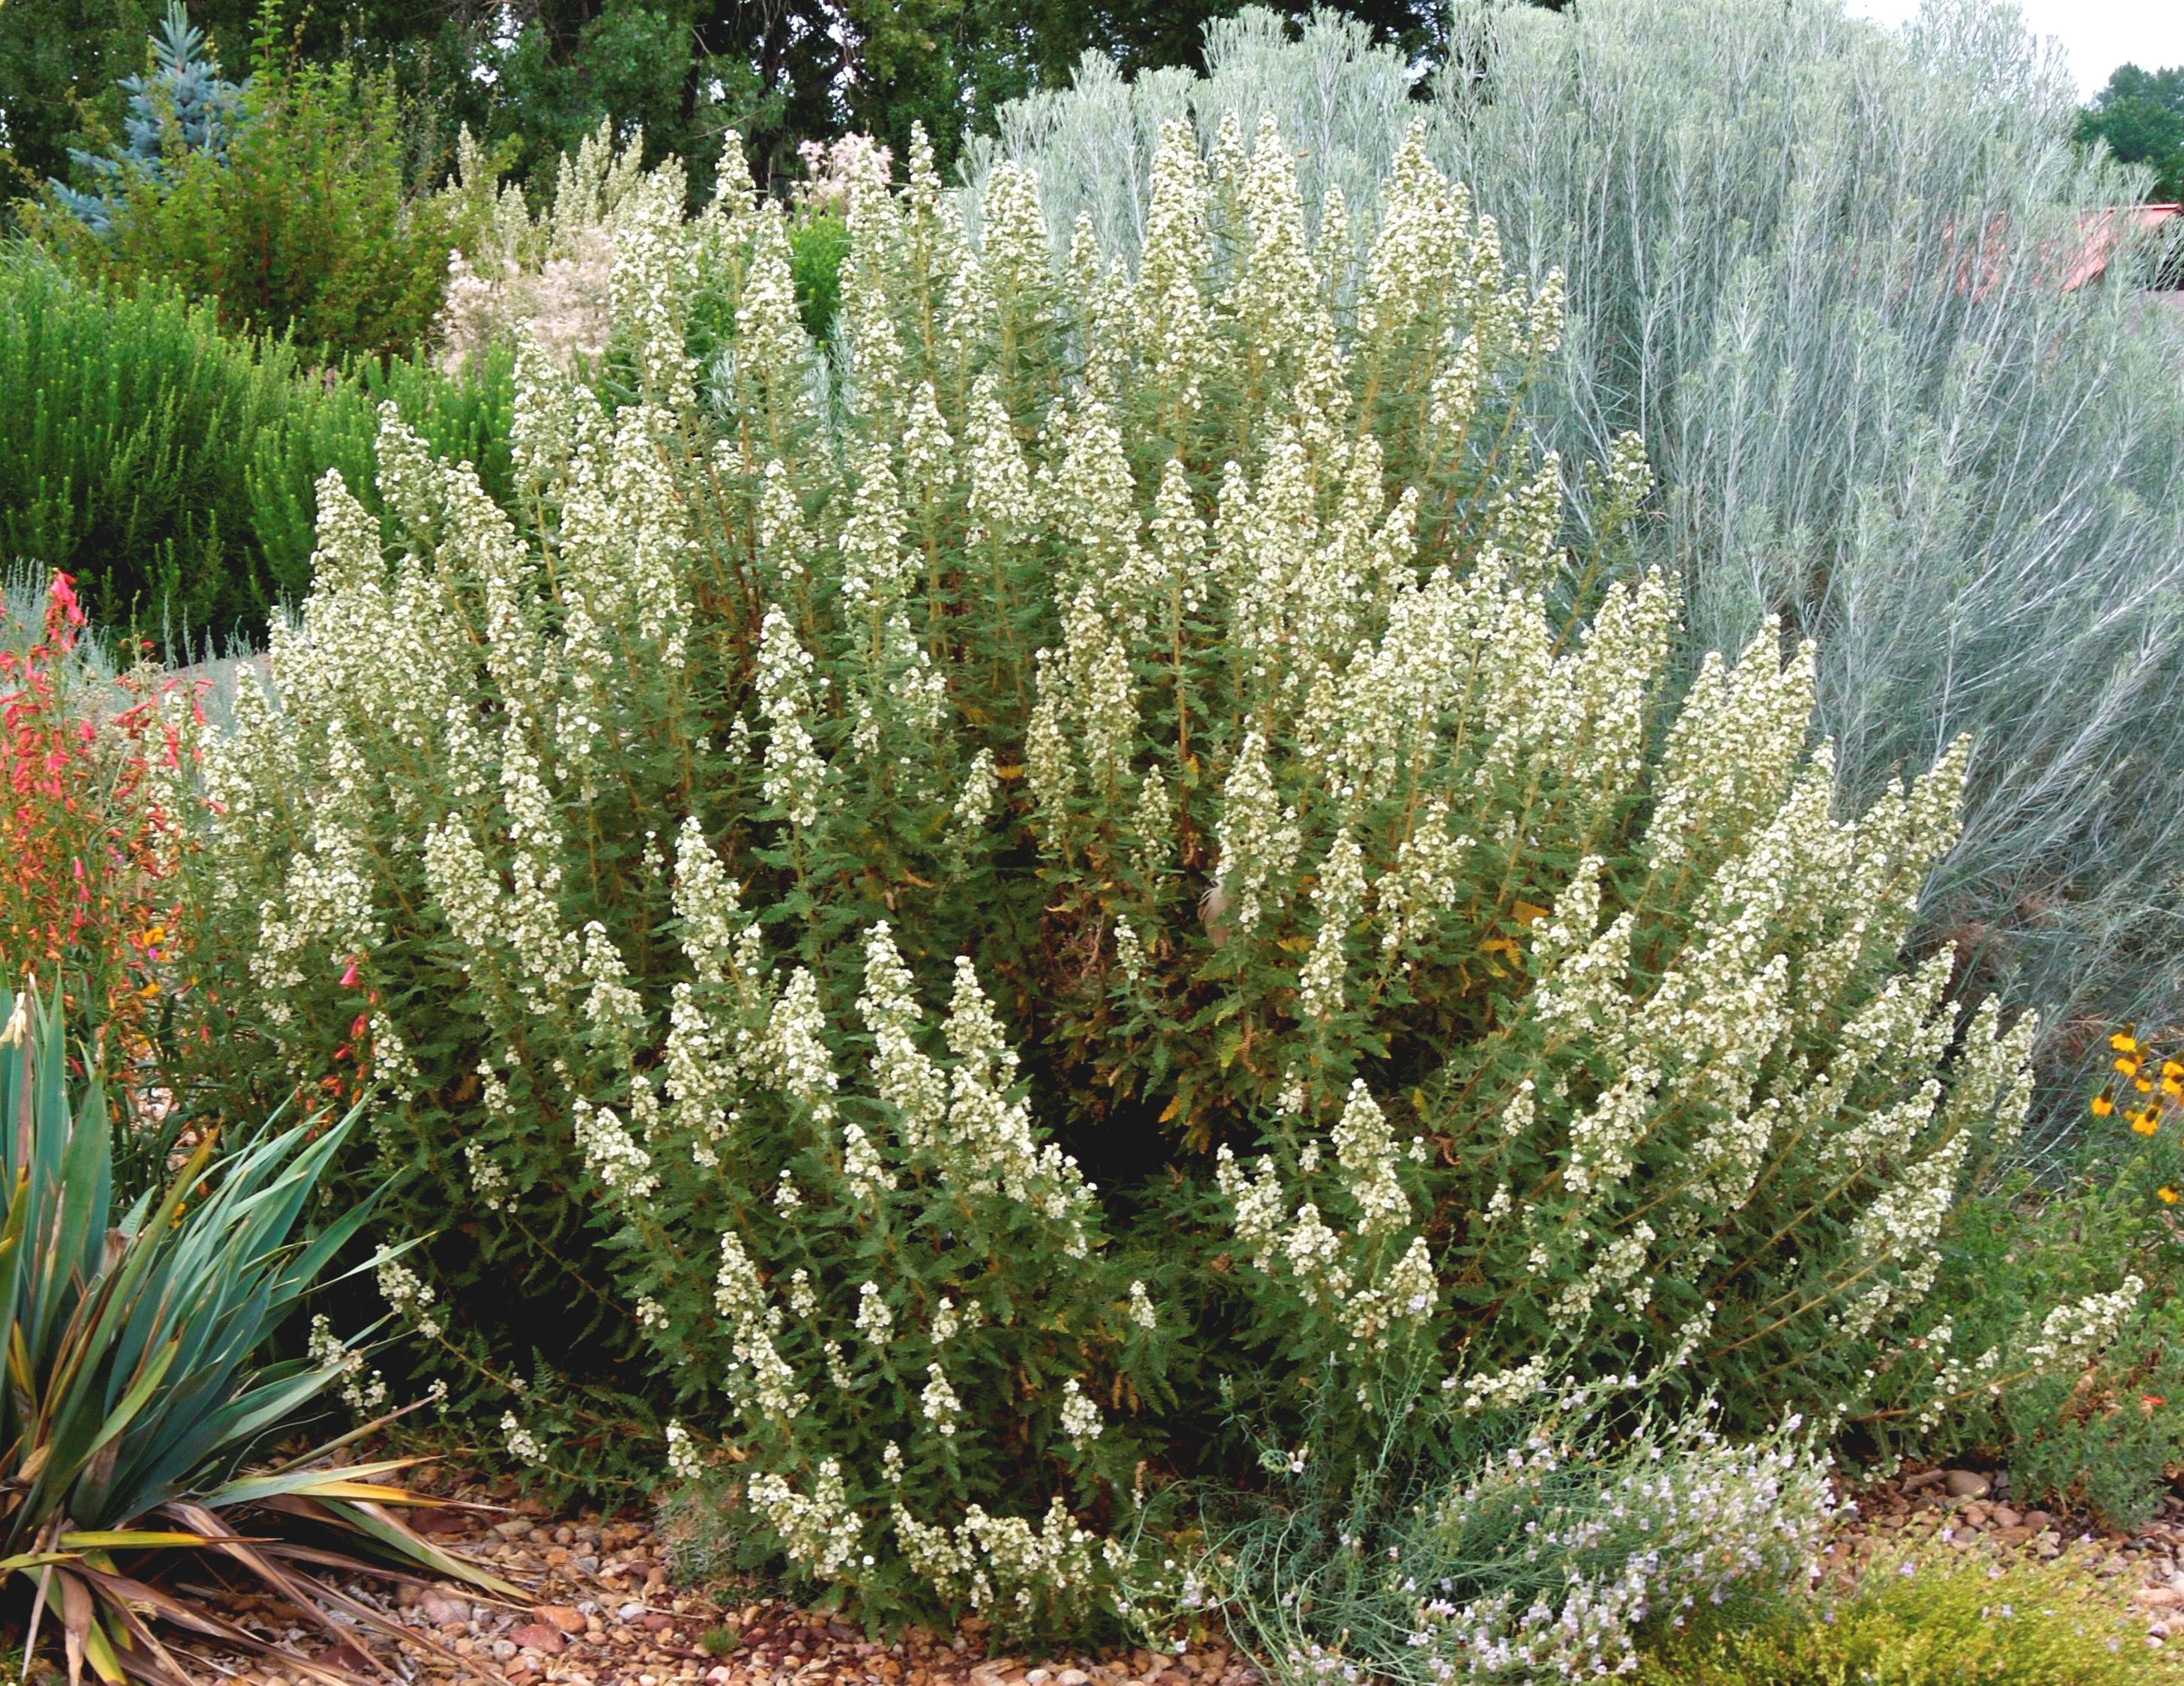




Height: 3-5’
Width: 3-5’
Blooms: July to August
Sun: Full sun to partial shade
Water: Moderate to xeric (once established)
Hardiness: USDA zones 5b-8 (up to 7,000’)
Culture: Garden loam, clay, or sandy soil
Introduced: 2006
Shrub
Intensely aromatic lacy foliage adorned with showy white flowers in midsummer. Makes formal mound with light pruning. Attractive winter seed heads and habit. A tough, adaptive Western native.

Fernbush
Chamaebatiaria millefolium
www.plantselect.org

