

**Fernbush**

*Chamaebatiaria millefolium*

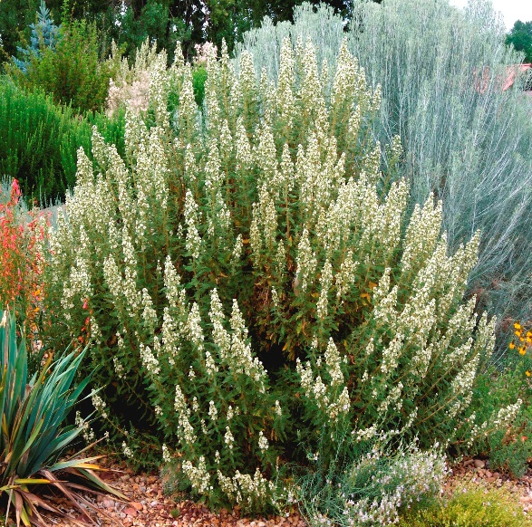

**Height: 3-5 ft. Width: 3-5 ft.**

Intensely aromatic lacy foliage adorned with showy white flowers in midsummer. Makes formal mound with light pruning. Attractive winter seed heads and habit. A tough, adaptive Western native.

**Culture:** Garden loam, clay, or sandy soil

**Hardiness:** USDA zones 5-8



WIND. HAIL. SNOW. SUN

**BRING IT ON**

www.plantselect.org

