
Littleleaf Mountain Mahogany
Cercocarpus intricatus

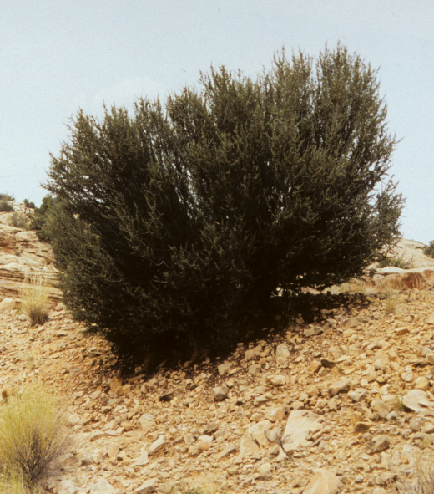




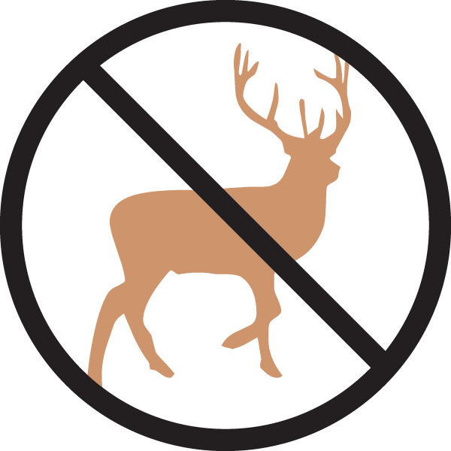


Height: 4-5 ft. Width: 3-4 ft.
This dense, twiggy evergreen shrub is from the Southwestern desert areas. A fine, small-scale hedge plant for a sunny, dry spot or as a specimen in the xeriscape. Small flowers transform into attractive, feathery seedpods. Responds to light pruning.
Culture: Clay, loam or sandy soil
Hardiness: USDA zones 3-9



WIND. HAIL. SNOW. SUN
BRING IT ON

www.plantselect.org



