

**Littleleaf Mountain Mahogany**

*Cercocarpus intricatus*

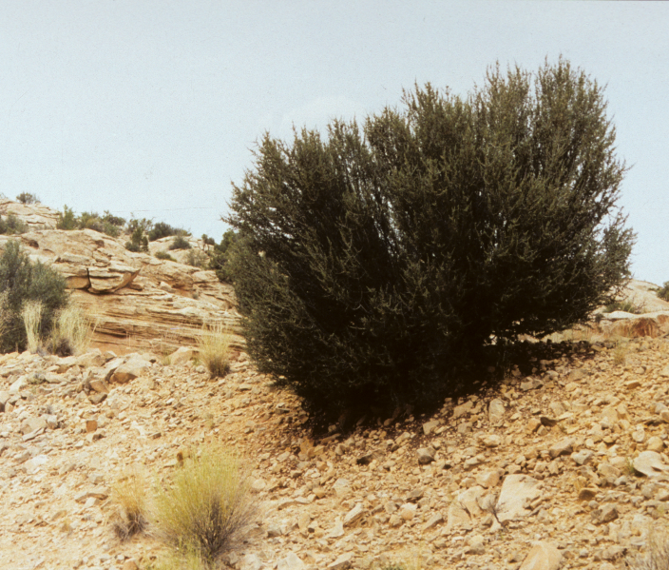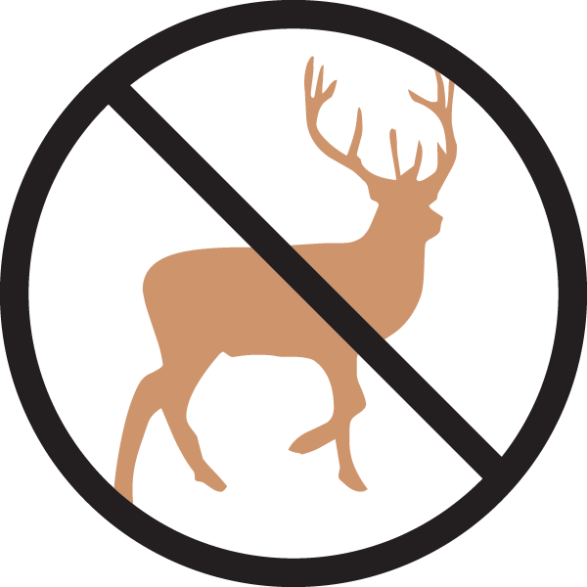

**Height: 4-5 ft. Width: 3-4 ft.**

This dense, twiggy evergreen shrub is from the Southwestern desert areas. A fine, small-scale hedge plant for a sunny, dry spot or as a specimen in the xeriscape. Small flowers transform into attractive, feathery seedpods. Responds to light pruning.

**Culture:** Clay, loam or sandy soil

**Hardiness:** USDA zones 3-9



WIND. HAIL. SNOW. SUN

**BRING IT ON**

www.plantselect.org

