


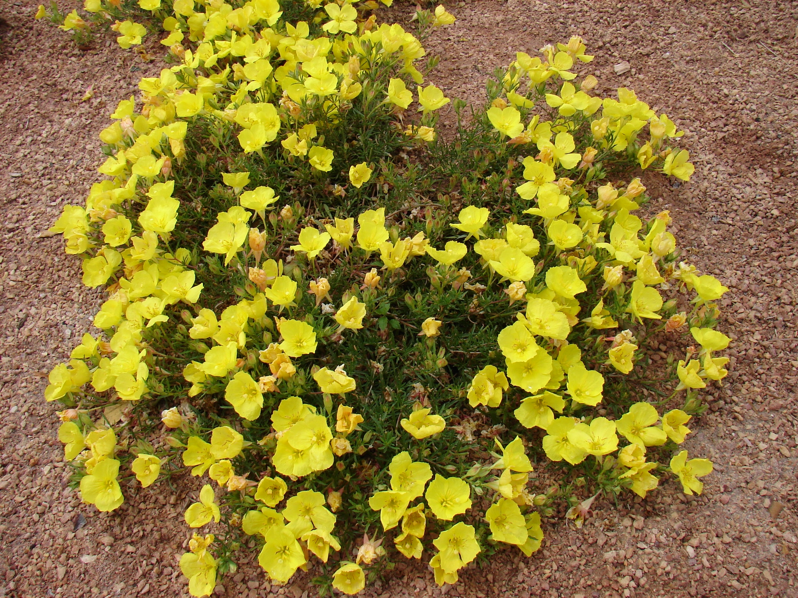
Height: 6-8”
Width: 12-15”
Blooms: May to September
Sun: Full sun to partial shade
Water: Moderate to xeric
Hardiness: USDA zones 3-9 (up to 9,000’)
Culture: Clay, sandy, or loam soils; lean soil best
Introduced: 2010
Perennial
This vigorous native prairie species is spangled for months on end with four-petalled, bright and cheerful yellow blossoms which emerge from large, orange buds. Tolerates a wide range of situations and thrives in hot, dry conditions. ‘Prairie Lode’ was selected by Bluebird Nursery in Clarkson, Nebraska for its compact habit. Cut back to ground each spring for best performance.

Prairie Lode Sundrops
Calylophus serrulatus ‘Prairie Lode’
www.plantselect.org

