
Prairie Lode Sundrops
Calylophus serrulatus ‘Prairie Lode’



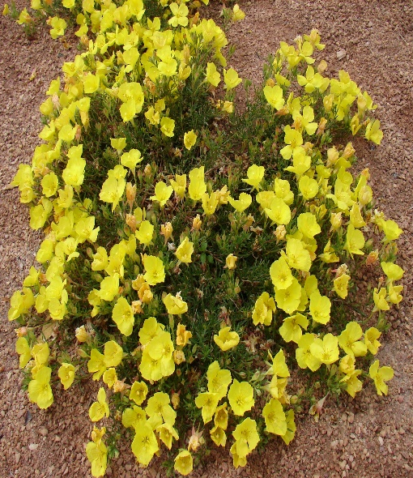
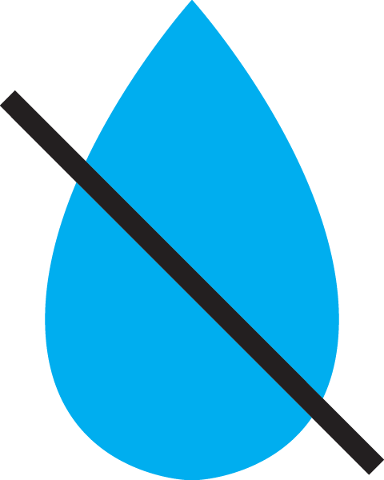




Height: 6-8 in. Width: 12-16 in.
This native prairie species is spangled nearly all season with bright yellow blossoms. Tolerates a wide range of situations and thrives in hot, dry conditions. Selected by Bluebird Nursery in Clarkson, Nebraska for its compact habit.
Culture: Clay, loam or sandy soil; lean soil best
Hardiness: USDA zones 5-9



WIND. HAIL. SNOW. SUN
BRING IT ON

www.plantselect.org



