

**Prairie Lode Sundrops**

*Calylophus serrulatus* ‘Prairie Lode’

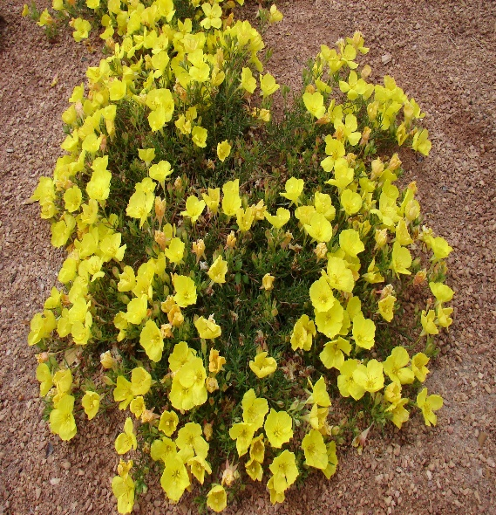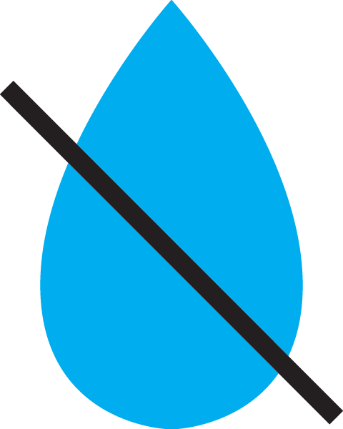

**Height: 6-8 in. Width: 12-16 in.**

This native prairie species is spangled nearly all season with bright yellow blossoms. Tolerates a wide range of situations and thrives in hot, dry conditions. Selected by Bluebird Nursery in Clarkson, Nebraska for its compact habit.

**Culture:** Clay, loam or sandy soil; lean soil best

**Hardiness:** USDA zones 5-9



WIND. HAIL. SNOW. SUN

**BRING IT ON**

www.plantselect.org

