
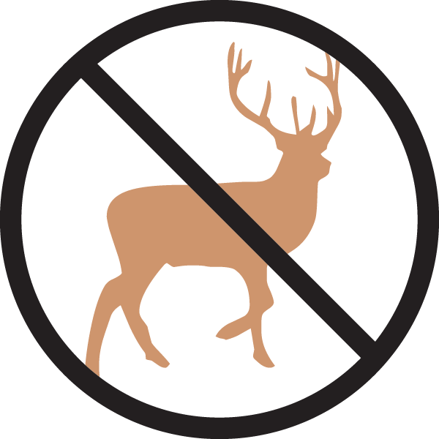

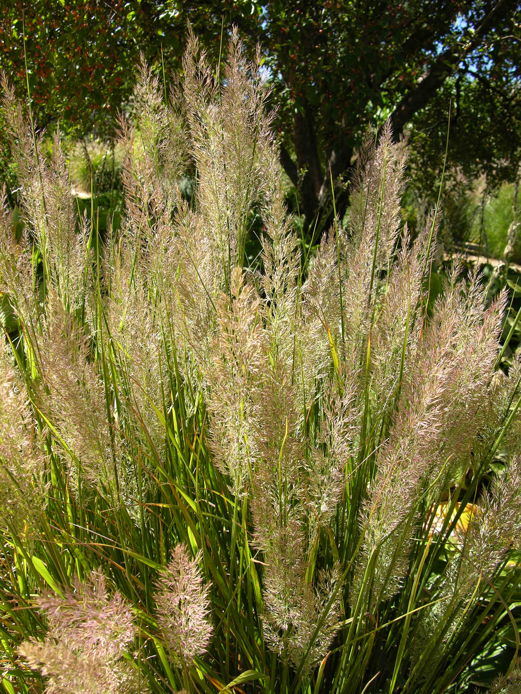
Height: 24-40”
Width: 12-15”
Blooms: August to October
Sun: Full sun to partial shade
Water: Moderate
Hardiness: USDA zones 4-9 (up to 8,000’)
Culture: Clay, sandy, or loamy soil
Introduced: 2009
Perennial
An elegant clump-forming grass that offers a fine alternative to Karl Foerster grass. With feathery summer flowers and attractive fall and winter presence, this grass suits a variety of sites and conditions.

Korean Feather Reed Grass
Calamagrostis brachytricha
www.plantselect.org

