
Korean Feather Reed Grass
Calamagrostis brachytricha

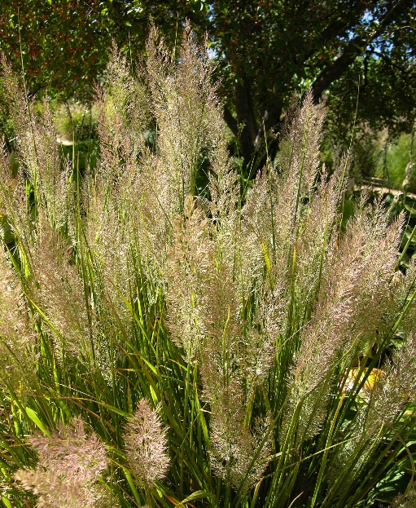
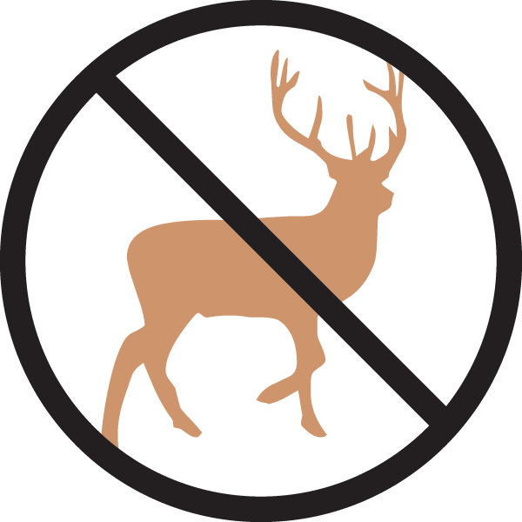





Height: 32-40 in. Width: 20-24 in.
An elegant clump-forming grass that offers a fine alternative to Karl Foerster grass. With feathery summer flowers and attractive fall and winter presence, this grass suits a variety of sites and conditions.
Culture: Clay, loam or sandy soil
Hardiness: USDA zones 4-9



WIND. HAIL. SNOW. SUN
BRING IT ON

www.plantselect.org



