

**Korean Feather Reed Grass**

*Calamagrostis brachytricha*

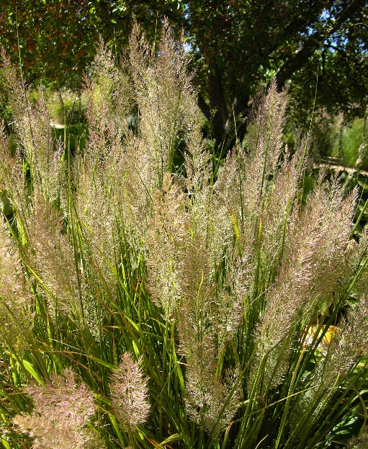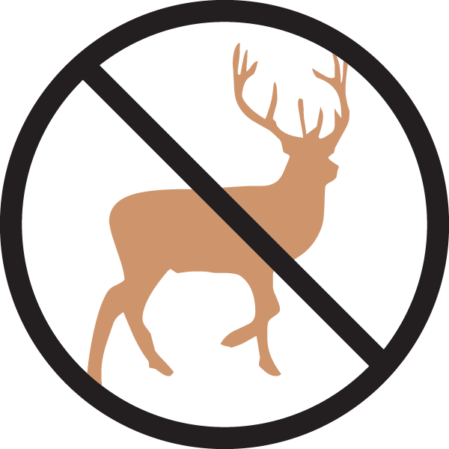

**Height: 32-40 in. Width: 20-24 in.**

An elegant clump-forming grass that offers a fine alternative to Karl Foerster grass. With feathery summer flowers and attractive fall and winter presence, this grass suits a variety of sites and conditions.

**Culture:** Clay, loam or sandy soil

**Hardiness:** USDA zones 4-9



WIND. HAIL. SNOW. SUN

**BRING IT ON**

www.plantselect.org

