
Silver Fountain Butterfly Bush
Buddleia alternifolia ‘Argentea’

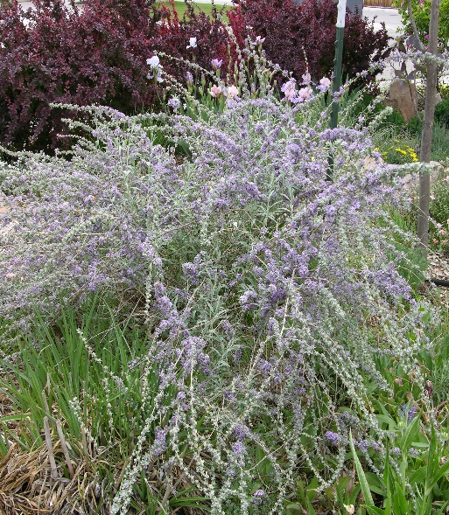






Height: 12-15 ft. Width: 10-12 ft.
The lavender to violet flowers are produced in mid-spring. The foliage is blue-gray or sometimes silver and finely textured. A small tree or large shrub, it blends well in a naturalistic design, shrub borders or as a specimen in a mixed border or lawn.
Culture: Loam
Hardiness: USDA zones 4-8



WIND. HAIL. SNOW. SUN
BRING IT ON

www.plantselect.org



