

**Silver Fountain Butterfly Bush**

*Buddleia alternifolia* ‘Argentea’

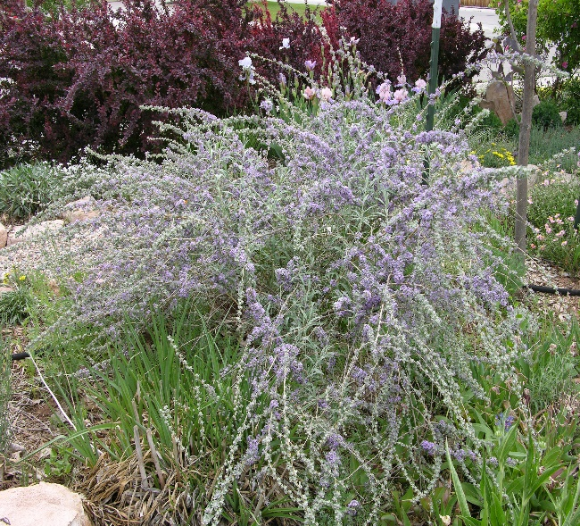

**Height: 12-15 ft. Width: 10-12 ft.**

The lavender to violet flowers are produced in mid-spring. The foliage is blue-gray or sometimes silver and finely textured. A small tree or large shrub, it blends well in a naturalistic design, shrub borders or as a specimen in a mixed border or lawn.

**Culture:** Loam

**Hardiness:** USDA zones 4-8



WIND. HAIL. SNOW. SUN

**BRING IT ON**

www.plantselect.org

