
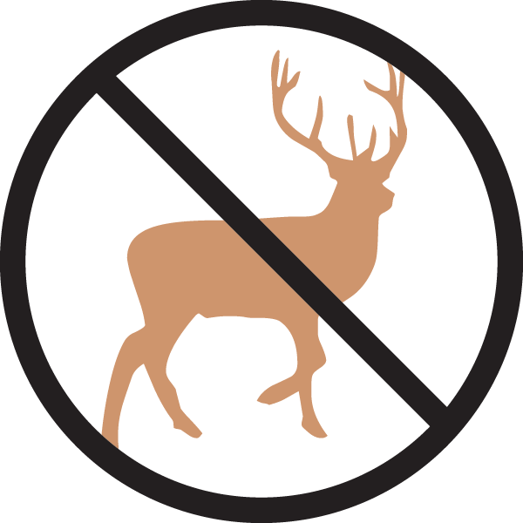


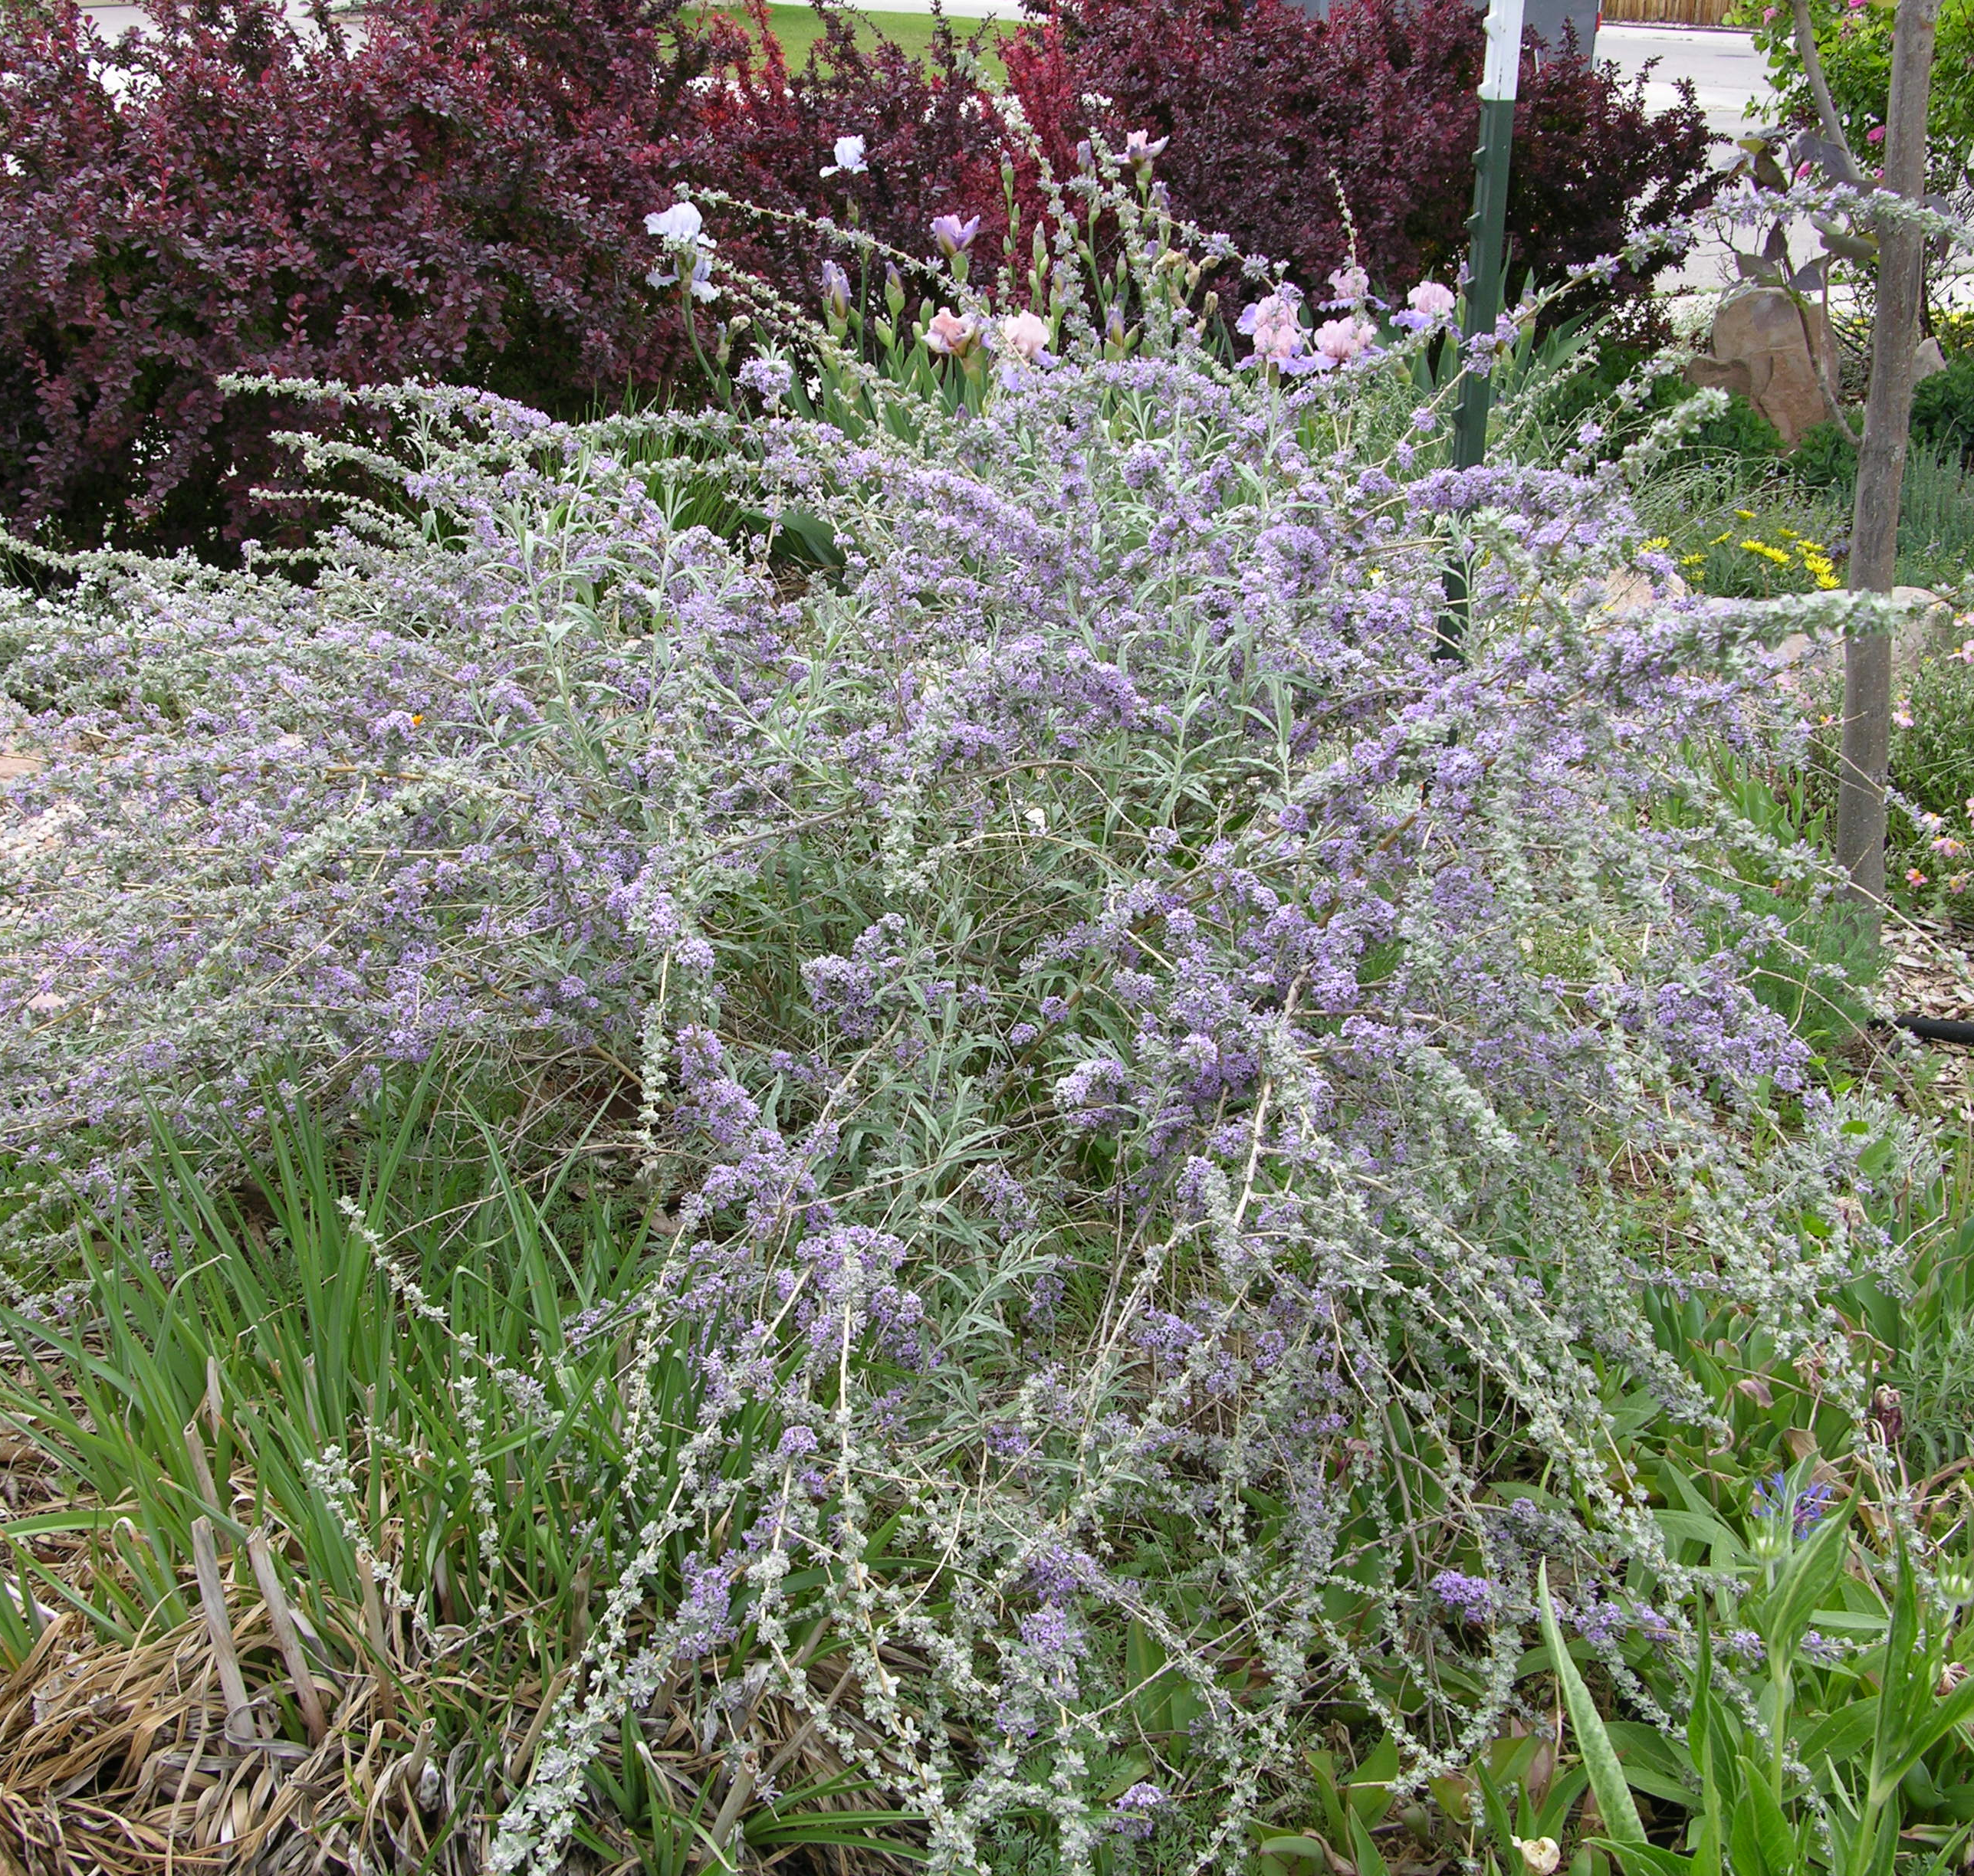
Height: 12-15’
Width: 10-12’
Blooms: Late spring
Sun: Full sun to partial shade
Water: Moderate watering; dislikes wet feet
Hardiness: USDA zones 4-8
Culture: Ordinary soil
Recommended: 1998
Large shrub or small tree
A small tree or a large shrub that does well in a variety of soils and sites. The lavender to violet flowers are produced in mid-spring. The foliage is blue-gray or sometimes silver and finely textured. It blends well in a naturalistic design, shrub borders or as a specimen in a mixed border or lawn.

Silver Fountain Butterfly Bush
Buddleia alternifolia ‘Argentea’
www.plantselect.org

