

**Blonde Ambition blue Grama Grass** *Bouteloua gracilis* ‘Blonde Ambition’ PP22,048

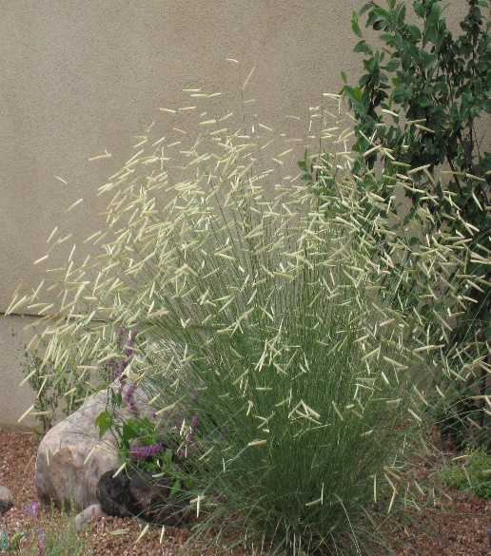

**Height: 28-32 in. Width: 28-32 in.**

Highly ornamental form of Western native grass with tall upright stems. Showy seed heads hold their straight shape and are displayed high above the foliage through winter, providing many months of color and texture. Developed by High Country gardens.

**Culture:** Clay, loam, or sandy soils

**Hardiness:** USDA zones 4-9



WIND. HAIL. SNOW. SUN

**BRING IT ON**

www.plantselect.org

