

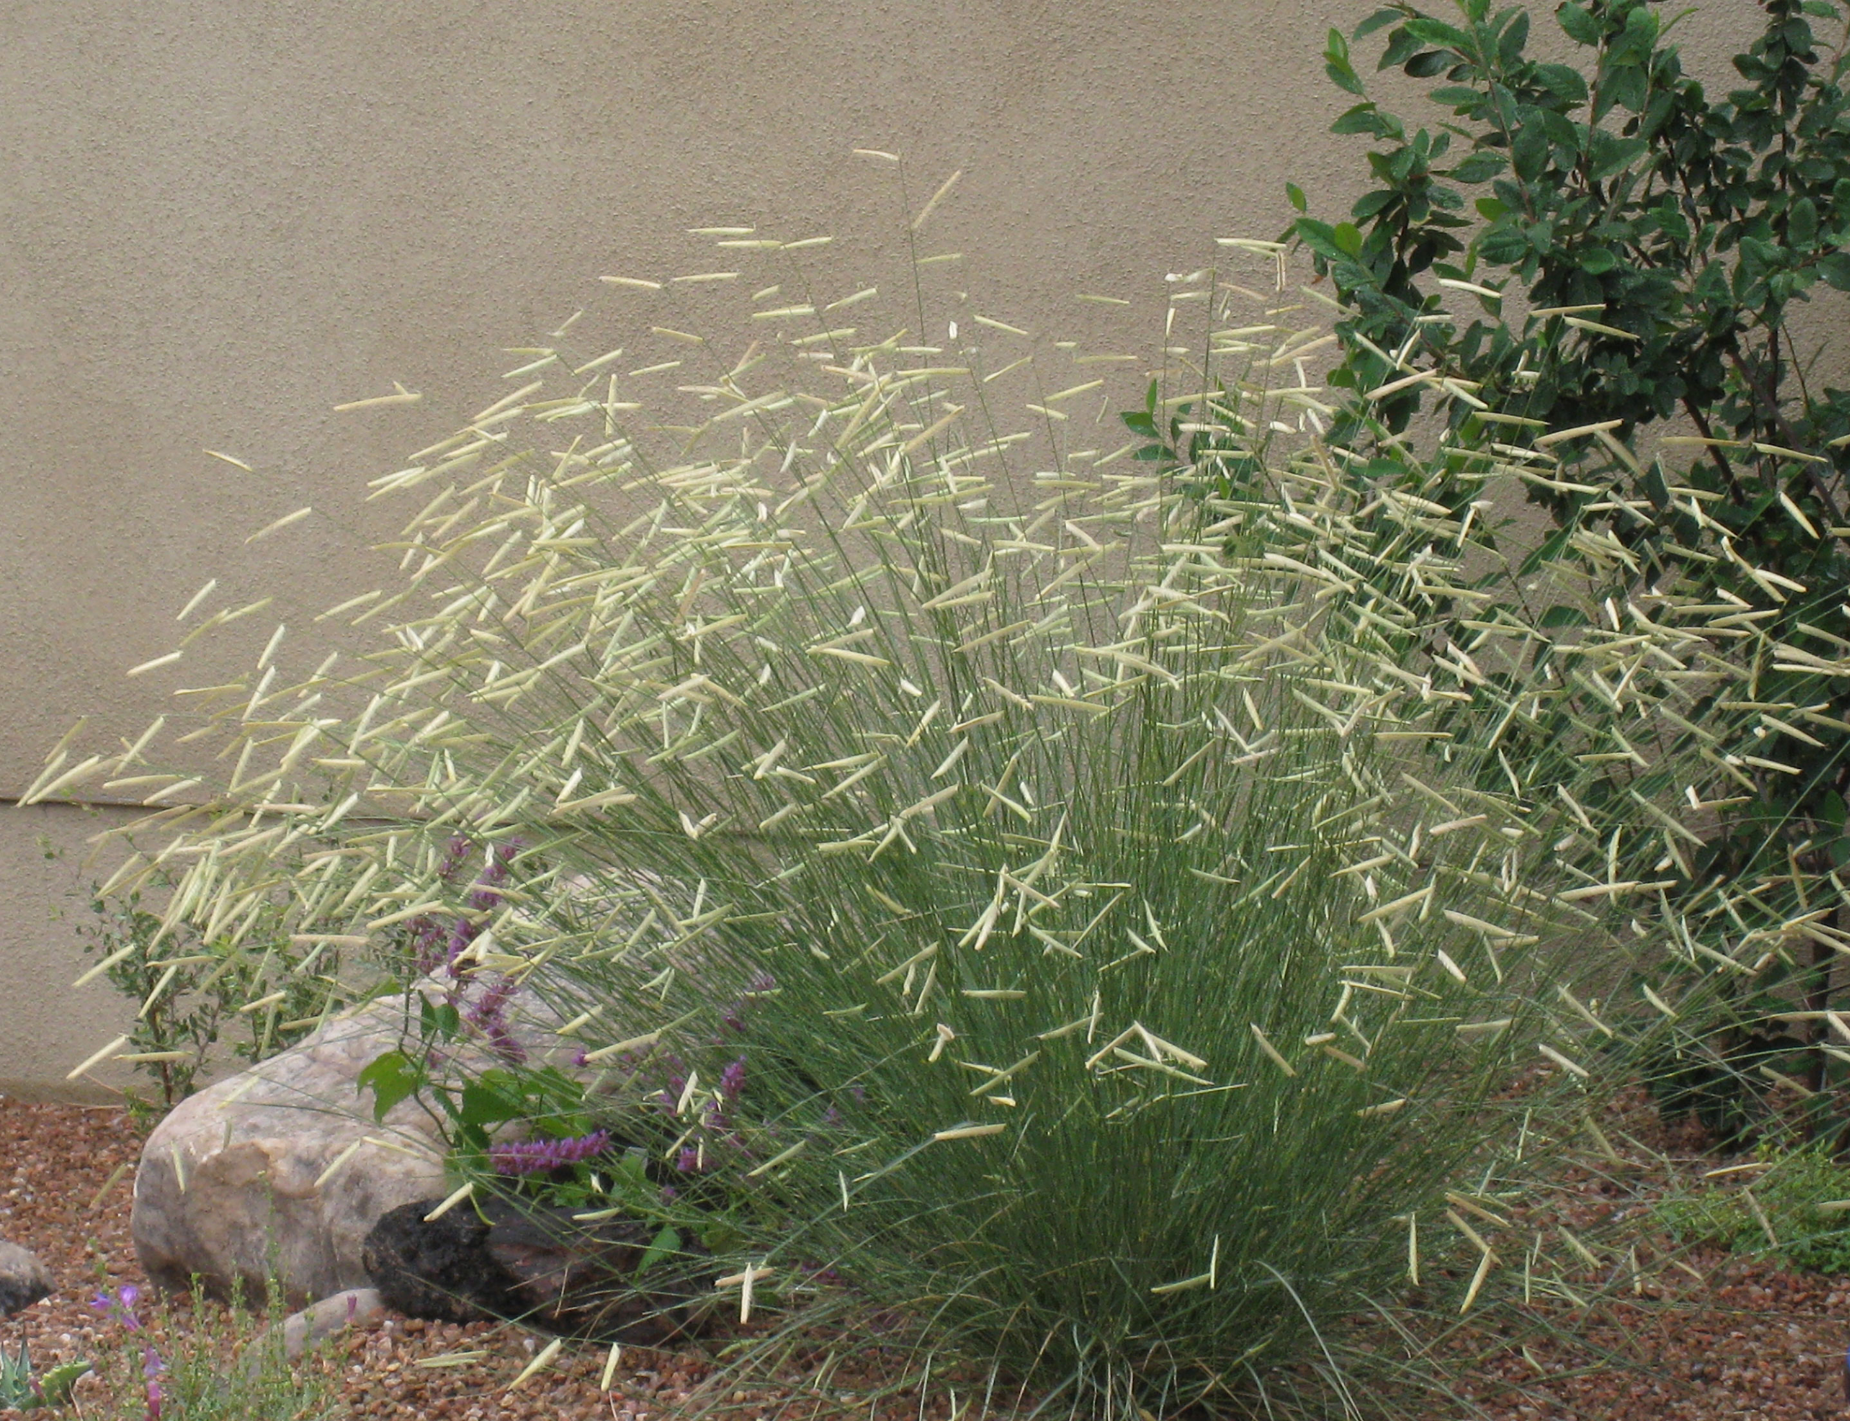
Height: 30-36”
Width: 30-36”
Blooms: July to October
Sun: Full sun to partial shade
Water: Moderate to dry
Hardiness: USDA zones 4-9 (up to 8,000’)
Culture: Clay, loam or sandy soils
Introduced: 2011
Perennial
An impressive, highly ornamental form of Western native grass with tall upright stems. Showy chartreuse, aging-to-blonde seed heads hold their straight shape and are displayed high above the foliage through winter, providing many months of color and texture. Developed by High Country gardens.

Blonde Ambition blue Grama Grass
Bouteloua gracilis ‘Blonde Ambition’ ^{PP22,048}
www.plantselect.org

