
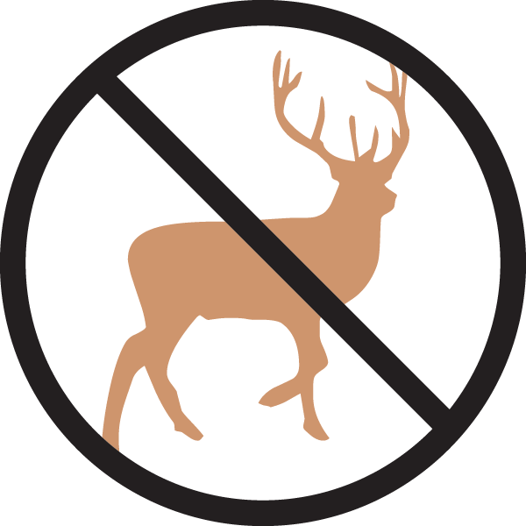


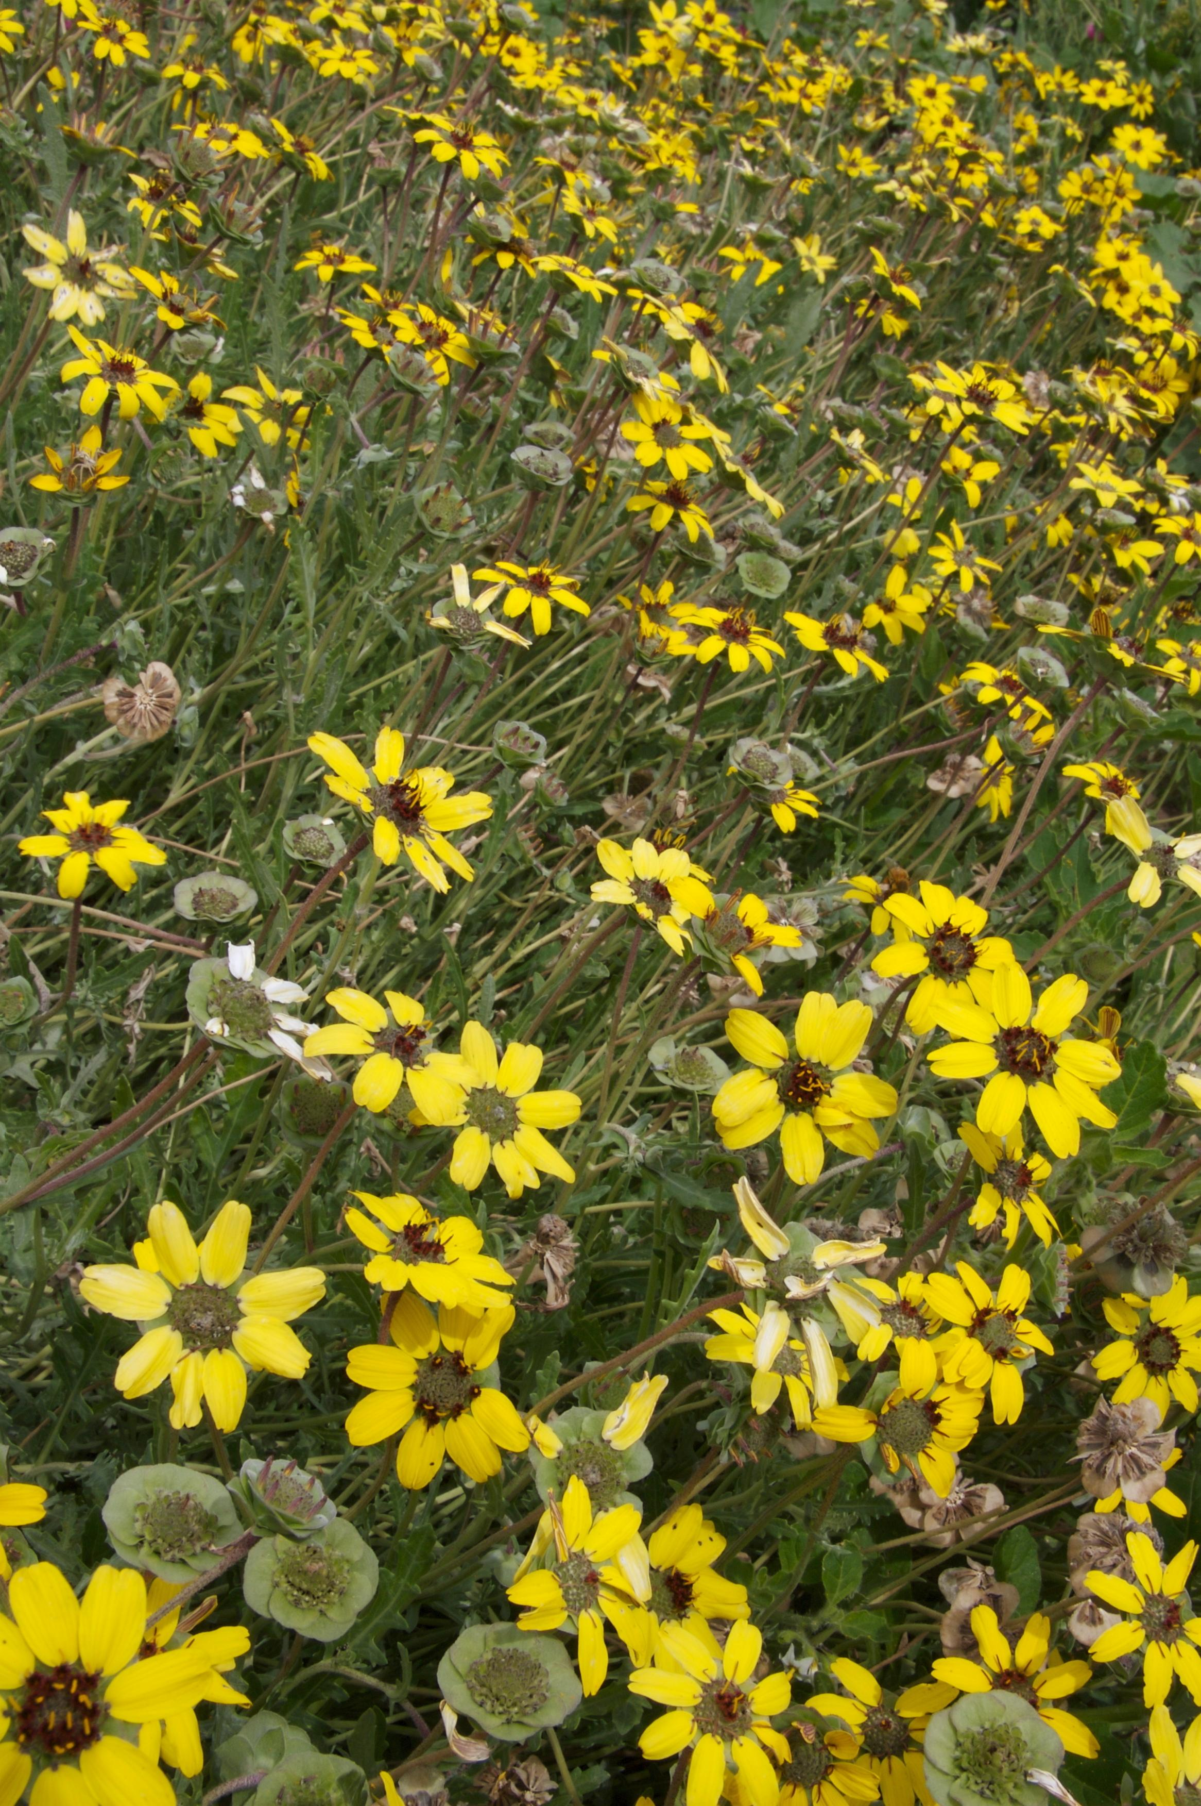
Height: 10-20”
Width: 10-20”
Blooms: May to September
Sun: Full sun to partial shade
Water: Dry (little to no water)
Hardiness: USDA zones 4-9
Culture: Poor dry soils
Introduced: 2004
Perennial
Ever blooming native wildflower from the Southwest that produces a continuous succession of dark-eyed, yellow daisies over a compact rosette of foliage. The flowers exude a rich chocolate aroma in the morning hours. Best with minimal water once established. Can reseed.

Chocolate Flower
Berlandiera lyrata
www.plantselect.org

